**LAPORAN PRAKTIKUM**

**PEMROGRAMAN WEB**

**Disusun Oleh:**

**Nama : Abid Saputra**

**NIM : 2170231055**

**Dosen Pembimbing:**

**Ali Khumaidi S.Kom, M.Kom**

**FAKULTAS TEKNIK**

**PRODI TEKNIK INFORMATIKA**

**UNIVERSITAS KRISNADWIPAYANA**

**2022**

**PERTEMUAN 1 (HTML)**

Latihan15

* Input

<html>

    <head>

        <tittle> Input Password </tittle>

        <body>

            Password : <input type = "password" name="nama" size="11" maxlength="9">

        </body>

    </head>

</html>

* output

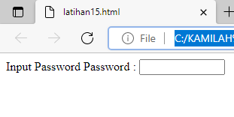

Latihan 16

* input

<html>

    <head>

        <title>Penggunaan Radio Button</title>

    </head>

    <body>

        jenis kelamin :

        <br>

        <input type="radio" name="jenis_kelamin" value="L"> Laki-Laki

        <br>

        <input type="radio" name="jenis_kelamin" value="P"> Perempuan

        <br>

    </body>

</html>

* output

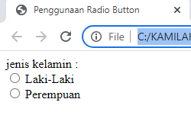

Latihan 17

* input

<html>

    <head>

        <title>Penggunaan Check Box</title>

    </head>

    <body>

        sebutkian hobi anda, boleh lebih dari satu :

        <br>

        <input type="checkbox" name="hobi_1" value="menonton"> menonton

        <br>

        <input type="checkbox" name="hobi_2" value="game"> game

        <br>

        <input type="checkbox" name="hobi_3" value="shopping"> shopping

        <br>

        <input type="checkbox" name="hobi_4" value="mancing"> mancing

        <br>

        <input type="checkbox" name="hobi_5" value="olahraga"> olahraga

        <br>

    </body>

</html>

* output

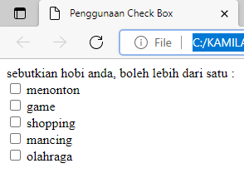

Latihan 18

* input

<html>

    <head>

        <title>Konfigurasi button</title>

    </head>

    <body>

        <form>

            <input type="submit" value="kirim" name="submit">

            <input type="reset" value="ulangi" name="reset">

            <input type="button" value="batal" name="button">

            <input type="image" value="gambar" img src="hellokitty.jpg" width="194" height="90">

        </form>

    </body>

</html>

* output

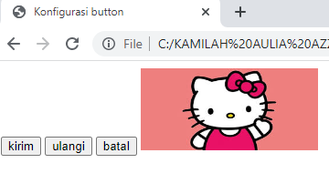

Latihan 19

* input

<html>

    <head>

        <tittle>Membuat Text Area</tittle>

    </head>

    <body>

        Deskripsi Diri :

        <br>

        <textarea name="deskripsi" cols="45" rows="5" align="center">Tuliskan deskripsi singkat tentang anda </textarea>

    </body>

</html>

* output

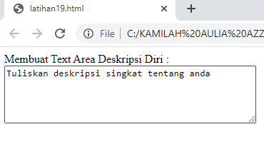

Latihan 20

* input

<html>

    <head>

        <title> Menggunakan Menu Dropdown </title>

    <head>

    <body>

        <img src="research.png" align="right">

    </img>

    <br>

    Silahkan Pilih orientasi minat :

    <br>

    <select name="Orientasi Minat">

        <option value="dg"> Design Grafis </option>

        <option value="pj"> Programmer Java </option>

        <option value="sa"> Sistem Analis </option>

        <option value="ds"> Dagelan Saja </option>

    </select>

    <br>

    <br>

    <select name="Orientasi Kemampuan" multiple>

        <option value="dg"> Design Grafis </option>

        <option value="pj"> Programmer Java </option>

        <option value="sa"> Sistem Analis </option>

        <option value="aj"> Ahli Jaringan </option>

        <option value="it"> Trainer IT </option>

        <option value="ds"> Dagelan Saja </option>

    </select>

    </body>

</html>

* output

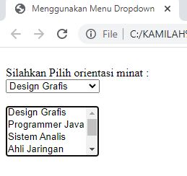

Home HTML

* input

<!DOCTYPE html>

<html>

<head>

    <title>Pertemuan 1</title>

</head>

<link rel="stylesheet" href="style.css">

<body>

    <header>

        <nav>

            <h1>HI, i'm Kamilah Aulia Azzahra</h1>

            <ul>

                <li><a href= "home.html">HOME</a></li>

                <li><a href= "menu.html">MENU</a></li>

                <li><a href= "contact.html">CONTACT</a></li>

            </ul>

        </nav>

    </header>

    <h1>HOME SAYA</h1>

    <table>

        <tr>

            <th>Nama</th>

            <th>Kelas</th>

            <th>NIM</th>

        </tr>

        <tr>

            <td>kamilah</td>

            <td>A1</td>

            <td>2170231053</td>

        </tr>

    </table>

</body>

</html>

* output

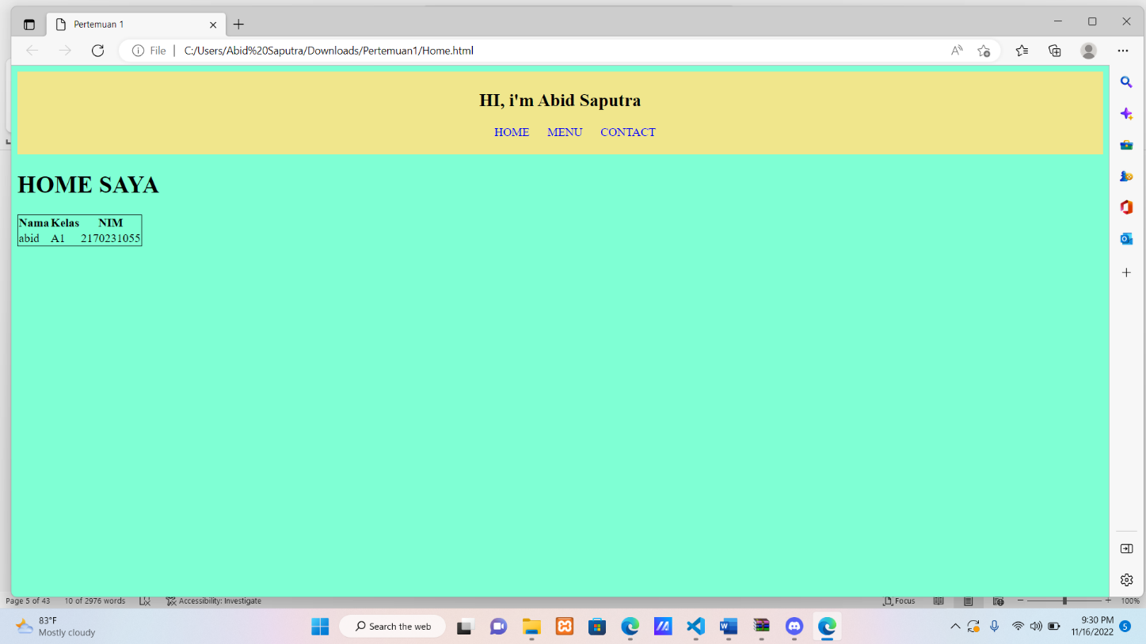

Menu HTML

* input

<!DOCTYPE html>

<html>

<head>

    <title>Pertemuan 1</title>

</head>

<link rel="stylesheet" href="style.css">

<body>

    <header>

        <nav>

            <h1>HI, i'm Abid Saputra</h1>

            <ul>

                <li><a href= "home.html">HOME</a></li>

                <li><a href= "menu.html">MENU</a></li>

                <li><a href= "contact.html">CONTACT</a></li>

            </ul>

        </nav>

    </header>

    <h1>MENU SAYA</h1>

</body>

</html>

* output

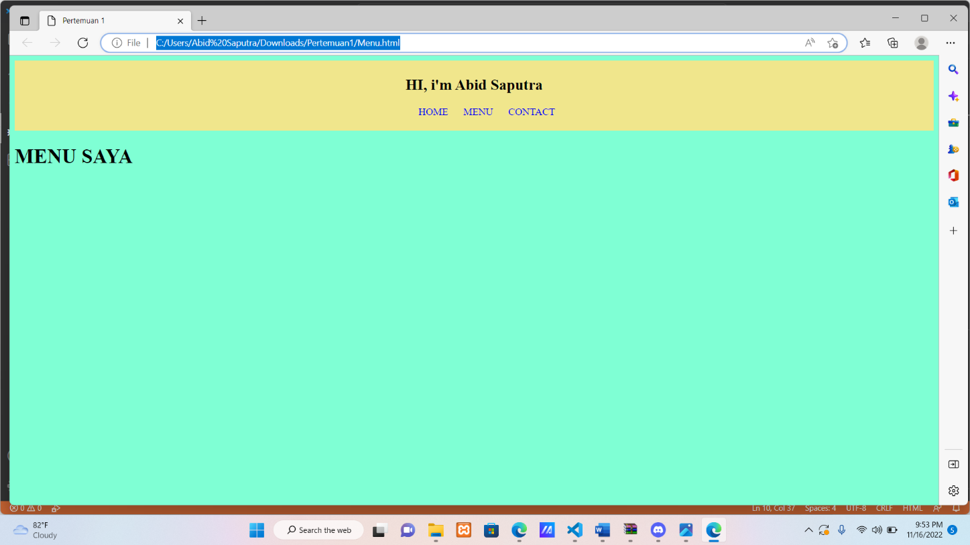

Contact HTML

* input

<!DOCTYPE html>

<html>

<head>

    <title>Pertemuan 1</title>

</head>

<link rel="stylesheet" href="style.css">

<body>

    <header>

        <nav>

            <h1>HI, i'm Abid Saputra</h1>

            <ul>

                <li><a href= "home.html">HOME</a></li>

                <li><a href= "menu.html">MENU</a></li>

                <li><a href= "contact.html">CONTACT</a></li>

            </ul>

        </nav>

    </header>

    <h1>CONTACT SAYA</h1>

</body>

</html>

* output

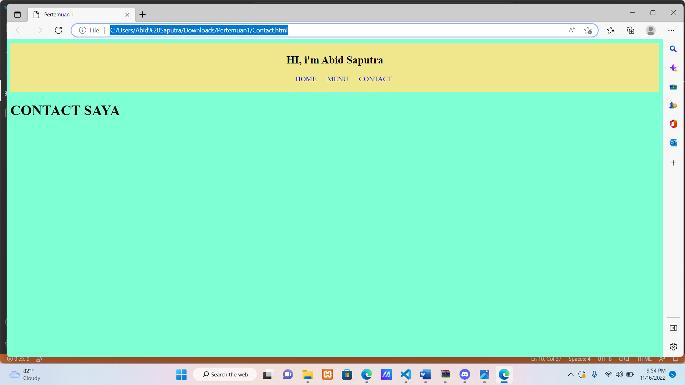

CSS

body{

    background-color: aquamarine;

}

ul{

    text-align: center;

}

li{

    display: inline;

}

a {

    text-decoration: none;

    margin: 10px;

}

a link {

    color: blue;

}

a:hover{

    /* background-color: blue; */

    text-decoration: underline;

}

a:visited {

    color:black

}

a:active {

    color:brown

}

header{

    background-color:khaki;

    padding: 5px;

    margin: auto;

    text-align: center;

}

table{

    border-collapse: collapse;

    border: 1px solid;

}

**TUGAS PERTEMUAN 1 (form HTML)**

* input

<!DOCTYPE html>

<html lang="en">

<head>

    <meta charset="UTF-8">

    <meta http-equiv="X-UA-Compatible" content="IE=edge">

    <meta name="viewport" content="width=device-width, initial-scale=1.0">

    <title>Document</title>

</head>

<body>

    <FONT SIZE=4>FORM PENDAFTARAN</FONT>

    <p>Nama:

        <input type="text" name="" id="">

    </p>

    <p>Gender:

        <input type="radio" name="" id="">Man

        <input type="radio" name="" id="">Women

    </p>

    <p> Address: <input type="text" name="" id="">

    </p>

<p>Country

    <select name="Country" id="">

        <option value="indonesia">Indonesia</option>

        <option value="malaysia">Malaysia</option>

        <option value="filipina">Filipina</option>

        <option value="vietnam">Vietnam</option>

    </select>

</p>

<p>Email:

    <input type="email" name="email">

    <input type="submit">

</p>

<p>Photo

    <input type="text" name="" id="">

    <input type="file" name="" id="">

</p>

<p>Comment:

    <textarea name="" id="" cols="40" rows="5"></textarea>

    </p>

</body>

</html>

* output

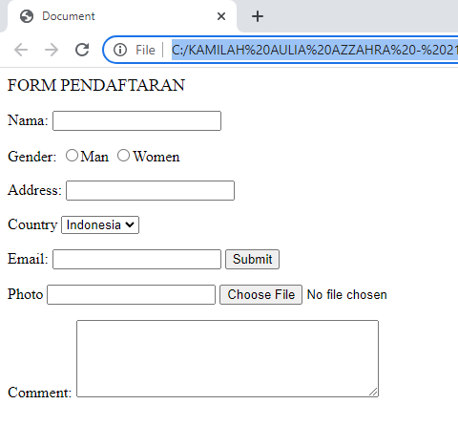

**PERTEMUAN 2 (HTML CSS)**

TUGAS MEMBUAT WEB PRIBADI

HTML

!DOCTYPE html>

<html lang="en">

<head>

  <meta charset="UTF-8">

  <meta name="viewport" content="width=device-width, initial-scale=1.0">

  <link rel="stylesheet" href="style.css">

  <title>My Website</title>

</head>

<body>

  <!-- Header -->

  <section id="header">

    <div class="header container">

      <div class="nav-bar">

        <div class="brand">

          <a href="#hero">

            <h1><span>A</span>bid <span>S</span>aputra</h1>

          </a>

        </div>

        <div class="nav-list">

          <div class="hamburger">

            <div class="bar"></div>

          </div>

          <ul>

            <li><a href="#hero" data-after="Home">Home</a></li>

            <li><a href="#services" data-after="Pendidikan">Pendidikan</a></li>

            <li><a href="#projects" data-after="Jadwal Kuliah">Jadwal Kuliah</a></li>

            <li><a href="#about" data-after="Akktivitas">Aktivitas</a></li>

            <li><a href="#contact" data-after="Contact">Kontak</a></li>

          </ul>

        </div>

      </div>

    </div>

  </section>

  <!-- End Header -->

  <!-- Hero Section  -->

  <section id="hero">

    <div class="hero container">

      <div>

        <h1>Hallo, <span></span></h1>

        <h1>Nama Saya <span></span></h1>

        <h1>Abid Saputra <span></span></h1>

        <a href="#projects" type="button" class="cta">jadwal kuliah</a>

      </div>

    </div>

  </section>

  <!-- End Hero Section  -->

  <!-- Service Section -->

  <section id="services">

    <div class="services container">

      <div class="service-top">

        <h1 class="section-title">Pen<span>didi</span>kan</h1>

        <p></p>

      </div>

      <div class="service-bottom">

        <div class="service-item">

          <div class="icon"><img src="https://img.icons8.com/bubbles/100/000000/services.png" /></div>

          <h2>SDN</h2>

          <p>2007 - 2013 ( SDN JATIRAHAYU IV KOTA BEKASI )</p>

        </div>

        <div class="service-item">

          <div class="icon"><img src="https://img.icons8.com/bubbles/100/000000/services.png" /></div>

          <h2>SMP</h2>

          <p>2013 - 2016 ( SMP SANDIKTA KOTA BEKASI )</p>

        </div>

        <div class="service-item">

          <div class="icon"><img src="https://img.icons8.com/bubbles/100/000000/services.png" /></div>

          <h2>SMK</h2>

          <p>2016 - 2020 ( SMK SANDIKTA KOTA BEKASI )</p>

        </div>

        <div class="service-item">

          <div class="icon"><img src="https://img.icons8.com/bubbles/100/000000/services.png" /></div>

          <h2>Mahasiswa</h2>

          <p>2021 - 2025 ( UNIVERSITAS KRSINADWIPAYANA )</p>

        </div>

      </div>

    </div>

  </section>

  <!-- End Service Section -->

  <!-- Projects Section -->

  <section id="projects">

    <div class="projects container">

      <div class="projects-header">

        <h1 class="section-title">Jadwal <span>Kuliah</span></h1>

      </div>

      <div class="all-projects">

        <div class="project-item">

          <div class="project-info">

            <h1>SELASA</h1>

            <h2>RUANGAN 308</h2>

            <p>TEORI GRAF & OTOMOTA (08.00 - 10.00)</p>

          </div>

          <div class="project-img">

            <img src="./img/belajar.jpg" alt="img">

          </div>

        </div>

        <div class="project-item">

          <div class="project-info">

            <h1>RABU</h1>

            <h2>RUANGAN 308</h2>

            <p>Komputasi Cerdas (08.00-10.00)  &  Statistik Probabilitas (15.00-16.30) </p>

          </div>

          <div class="project-img">

            <img src="./img/belajar.jpg" alt="img">

          </div>

        </div>

        <div class="project-item">

          <div class="project-info">

            <h1>KAMIS</h1>

            <h2>RUANGAN 409 & 309</h2>

            <p>Pemrograman Web (10.00-12.30) Ruangan & Basis Data Lanjutan (15.00-17.30)</p>

          </div>

          <div class="project-img">

            <img src="./img/belajar.jpg" alt="img">

          </div>

        </div>

        <div class="project-item">

          <div class="project-info">

            <h1>JUMAT</h1>

            <h2>RUANGAN 203 & 312</h2>

            <p>Bahasa Ingrris 2 (13.00-14.40) Ruangan & Grafika Komputer (15.00-17.00)</p>

          </div>

          <div class="project-img">

            <img src="./img/belajar.jpg" alt="img">

          </div>

        </div>

        <div class="project-item">

          <div class="project-info">

            <h1>SABTU</h1>

            <h2>RUANGAN 203</h2>

            <p>Matematika Diskrit (09.00-10.00)</p>

          </div>

          <div class="project-img">

            <img src="./img/belajar.jpg" alt="img">

          </div>

        </div>

      </div>

    </div>

  </section>

  <!-- End Projects Section -->

  <!-- About Section -->

  <section id="about">

    <div class="about container">

      <div class="col-left">

        <div class="about-img">

          <img src="./img/profile-img" alt="img">

        </div>

      </div>

      <div class="col-right">

        <h1 class="section-title">Aktivitas <span>Saya</span></h1>

        <h2>Kegiatan</h2>

        <p>Mau Tahu Profesi Joki Game Online, Begini Penjelasannya

          Nah, joki ternyata ada di berbagai bidang lho, tak terkecuali dalam bidang game. Apa sih sebenarnya yang mereka lakukan?  Kita mungkin mengenal profesi seperti joki kuda, joki balap motor, sampai joki 3-in-1. Tetapi kali ini, ada yang menarik perhatian Duniagames mengenai profesi joki. Bukan hal baru memang, namun hal ini sangat membuat Duniagames merasa heran, karena ternyata di dunia game online pun mulai dikenal istilah joki.

          Berdasarkan informasi yang Duniagames himpun dari berbagai sumber, para joki game ini bertugas untuk menaikkan level game atau untuk mendapatkan item tertentu dalam game. Umumnya para joki game ini memainkan akun dari penyewa jasa mereka.

          Joki game ini merupakan orang-orang profesional dalam bidang game. Mereka adalah orang-orang yang handal dan mampu memainkan game hingga berjam-jam, sehingga kemampuan mereka dapat “diperjual-belikan” untuk para gamer yang ingin bermain game secara instan dan butuh eksistensi dalam dunia game. Kemampuannya ini tentu akan diganjar dengan bayaran yang menggiurkan.

          Kamu pernah nggak sih bertanya soal “Bagaimana mungkin para gamer bisa dianggap sebagai seorang atlet? Kok bisa bisa mainin game smartphone aja dianggap sebagai aktivitas olahraga?”

Untuk mеnjаwаb hаl itu, аdа bаiknyа mеngеtаhui tеrlеbih dаhulu ара аrtinyа sроrt. Sроrt mеmiliki dеfinisi umum sеbаgаi sеgаlа kеgiаtаn yаng mеmiliki аktifitаs fisik, mеlаlui раrtisiраsi kаsuаl аtаuрun tеrоgаnisir dеngаn tujuаn untuk mеngеksрrеsikаn аtаu mеningkаtkаn kеmаmрuаn fisik dаn mеntаl yаng dараt jugа digunаkаn untuk hubungаn sоsiаl аtаu mеrаih рrеstаsi.

          </p>

        <a href="#" class="cta">Download</a>

      </div>

    </div>

  </section>

  <!-- End About Section -->

  <!-- Contact Section -->

  <section id="contact">

    <div class="contact container">

      <div>

        <h1 class="section-title">Info <span>Kontak</span></h1>

      </div>

      <div class="contact-items">

        <div class="contact-item">

          <div class="icon"><img src="https://img.icons8.com/bubbles/100/000000/phone.png" /></div>

          <div class="contact-info">

            <h1>No Telp</h1>

            <h2>+62 132 460 0790</h2>

            <h2>+62 132 460 0790</h2>

          </div>

        </div>

        <div class="contact-item">

          <div class="icon"><img src="https://img.icons8.com/bubbles/100/000000/new-post.png" /></div>

          <div class="contact-info">

            <h1>Email</h1>

            <h2>abidsaputra0@gmail.com</h2>

            <h2>abidsaputra8@gmail.com</h2>

          </div>

        </div>

        <div class="contact-item">

          <div class="icon"><img src="https://img.icons8.com/bubbles/100/000000/map-marker.png" /></div>

          <div class="contact-info">

            <h1>Alamat</h1>

            <h2>Pondok Gede, Bekasi, Jawa Barat</h2>

          </div>

        </div>

      </div>

    </div>

  </section>

  <!-- End Contact Section -->

  <!-- Footer -->

  <section id="footer">

    <div class="footer container">

      <div class="brand">

        <h1><span>A</span>BID <span>S</span>APUTRA</h1>

      </div>

      <h2>Your Complete Web Solution</h2>

      <div class="social-icon">

        <div class="social-item">

          <a href="#"><img src="https://img.icons8.com/bubbles/100/000000/facebook-new.png" /></a>

        </div>

        <div class="social-item">

          <a href="#"><img src="https://img.icons8.com/bubbles/100/000000/instagram-new.png" /></a>

        </div>

        <div class="social-item">

          <a href="#"><img src="https://img.icons8.com/bubbles/100/000000/twitter.png" /></a>

        </div>

        <div class="social-item">

          <a href="#"><img src="https://img.icons8.com/bubbles/100/000000/behance.png" /></a>

        </div>

      </div>

      <p>Copyright © 2022 Abid. All rights reserved</p>

    </div>

  </section>

  <!-- End Footer -->

  <script src="./app.js"></script>

</body>

</html>

</section>

<!-- home section ends -->

</body>

</html>

CSS

@import 'https://fonts.googleapis.com/css?family=Montserrat:300, 400, 700&display=swap';

* {

    padding: 0;

    margin: 0;

    box-sizing: border-box;

}

html {

    font-size: 10px;

    font-family: 'Montserrat', sans-serif;

    scroll-behavior: smooth;

}

a {

    text-decoration: none;

}

.container {

    min-height: 100vh;

    width: 100%;

    display: flex;

    align-items: center;

    justify-content: center;

}

img {

    height: 100%;

    width: 100%;

    object-fit: cover;

}

p {

    color: black;

    font-size: 1.4rem;

    margin-top: 5px;

    line-height: 2.5rem;

    font-weight: 300;

    letter-spacing: 0.05rem;

}

.section-title {

    font-size: 4rem;

    font-weight: 300;

    color: black;

    margin-bottom: 10px;

    text-transform: uppercase;

    letter-spacing: 0.2rem;

    text-align: center;

}

.section-title span {

    color: crimson;

}

.cta {

    display: inline-block;

    padding: 10px 30px;

    color: white;

    background-color: transparent;

    border: 2px solid crimson;

    font-size: 2rem;

    text-transform: uppercase;

    letter-spacing: 0.1rem;

    margin-top: 30px;

    transition: 0.3s ease;

    transition-property: background-color, color;

}

.cta:hover {

    color: white;

    background-color: crimson;

}

.brand h1 {

    font-size: 3rem;

    text-transform: uppercase;

    color: white;

}

.brand h1 span {

    color: crimson;

}

/* Header section */

#header {

    position: fixed;

    z-index: 1000;

    left: 0;

    top: 0;

    width: 100vw;

    height: auto;

}

#header .header {

    min-height: 8vh;

    background-color: rgba(31, 30, 30, 0.24);

    transition: 0.3s ease background-color;

}

#header .nav-bar {

    display: flex;

    align-items: center;

    justify-content: space-between;

    width: 100%;

    height: 100%;

    max-width: 1300px;

    padding: 0 10px;

}

#header .nav-list ul {

    list-style: none;

    position: absolute;

    background-color: rgb(31, 30, 30);

    width: 100vw;

    height: 100vh;

    left: 100%;

    top: 0;

    display: flex;

    flex-direction: column;

    justify-content: center;

    align-items: center;

    z-index: 1;

    overflow-x: hidden;

    transition: 0.5s ease left;

}

#header .nav-list ul.active {

    left: 0%;

}

#header .nav-list ul a {

    font-size: 2.5rem;

    font-weight: 500;

    letter-spacing: 0.2rem;

    text-decoration: none;

    color: white;

    text-transform: uppercase;

    padding: 20px;

    display: block;

}

#header .nav-list ul a::after {

    content: attr(data-after);

    position: absolute;

    top: 50%;

    left: 50%;

    transform: translate(-50%, -50%) scale(0);

    color: rgba(240, 248, 255, 0.021);

    font-size: 13rem;

    letter-spacing: 50px;

    z-index: -1;

    transition: 0.3s ease letter-spacing;

}

#header .nav-list ul li:hover a::after {

    transform: translate(-50%, -50%) scale(1);

    letter-spacing: initial;

}

#header .nav-list ul li:hover a {

    color: crimson;

}

#header .hamburger {

    height: 60px;

    width: 60px;

    display: inline-block;

    border: 3px solid white;

    border-radius: 50%;

    position: relative;

    display: flex;

    align-items: center;

    justify-content: center;

    z-index: 100;

    cursor: pointer;

    transform: scale(0.8);

    margin-right: 20px;

}

#header .hamburger:after {

    position: absolute;

    content: '';

    height: 100%;

    width: 100%;

    border-radius: 50%;

    border: 3px solid white;

    animation: hamburger_puls 1s ease infinite;

}

#header .hamburger .bar {

    height: 2px;

    width: 30px;

    position: relative;

    background-color: white;

    z-index: -1;

}

#header .hamburger .bar::after,

#header .hamburger .bar::before {

    content: '';

    position: absolute;

    height: 100%;

    width: 100%;

    left: 0;

    background-color: white;

    transition: 0.3s ease;

    transition-property: top, bottom;

}

#header .hamburger .bar::after {

    top: 8px;

}

#header .hamburger .bar::before {

    bottom: 8px;

}

#header .hamburger.active .bar::before {

    bottom: 0;

}

#header .hamburger.active .bar::after {

    top: 0;

}

/* End Header section */

/* Hero Section */

#hero {

    background-image: url(./img/hero-bg.png);

    background-size: cover;

    background-position: top center;

    position: relative;

    z-index: 1;

}

#hero::after {

    content: '';

    position: absolute;

    left: 0;

    top: 0;

    height: 100%;

    width: 100%;

    background-color: black;

    opacity: 0.7;

    z-index: -1;

}

#hero .hero {

    max-width: 1200px;

    margin: 0 auto;

    padding: 0 50px;

    justify-content: flex-start;

}

#hero h1 {

    display: block;

    width: fit-content;

    font-size: 4rem;

    position: relative;

    color: transparent;

    animation: text_reveal 0.5s ease forwards;

    animation-delay: 1s;

}

#hero h1:nth-child(1) {

    animation-delay: 1s;

}

#hero h1:nth-child(2) {

    animation-delay: 2s;

}

#hero h1:nth-child(3) {

    animation: text_reveal_name 0.5s ease forwards;

    animation-delay: 3s;

}

#hero h1 span {

    position: absolute;

    top: 0;

    left: 0;

    height: 100%;

    width: 0;

    background-color: crimson;

    animation: text_reveal_box 1s ease;

    animation-delay: 0.5s;

}

#hero h1:nth-child(1) span {

    animation-delay: 0.5s;

}

#hero h1:nth-child(2) span {

    animation-delay: 1.5s;

}

#hero h1:nth-child(3) span {

    animation-delay: 2.5s;

}

/* End Hero Section */

/* Services Section */

#services .services {

    flex-direction: column;

    text-align: center;

    max-width: 1500px;

    margin: 0 auto;

    padding: 100px 0;

}

#services .service-top {

    max-width: 500px;

    margin: 0 auto;

}

#services .service-bottom {

    display: flex;

    align-items: center;

    justify-content: center;

    flex-wrap: wrap;

    margin-top: 50px;

}

#services .service-item {

    flex-basis: 80%;

    display: flex;

    align-items: flex-start;

    justify-content: center;

    flex-direction: column;

    padding: 30px;

    border-radius: 10px;

    background-image: url(./img/img-1.png);

    background-size: cover;

    margin: 10px 5%;

    position: relative;

    z-index: 1;

    overflow: hidden;

}

#services .service-item::after {

    content: '';

    position: absolute;

    left: 0;

    top: 0;

    height: 100%;

    width: 100%;

    background-image: linear-gradient(60deg, #29323c 0%, #485563 100%);

    opacity: 0.9;

    z-index: -1;

}

#services .service-bottom .icon {

    height: 80px;

    width: 80px;

    margin-bottom: 20px;

}

#services .service-item h2 {

    font-size: 2rem;

    color: white;

    margin-bottom: 10px;

    text-transform: uppercase;

}

#services .service-item p {

    color: white;

    text-align: left;

}

/* End Services Section */

/* Projects section */

#projects .projects {

    flex-direction: column;

    max-width: 1200px;

    margin: 0 auto;

    padding: 100px 0;

}

#projects .projects-header h1 {

    margin-bottom: 50px;

}

#projects .all-projects {

    display: flex;

    align-items: center;

    justify-content: center;

    flex-direction: column;

}

#projects .project-item {

    display: flex;

    align-items: center;

    justify-content: center;

    flex-direction: column;

    width: 80%;

    margin: 20px auto;

    overflow: hidden;

    border-radius: 10px;

}

#projects .project-info {

    padding: 30px;

    flex-basis: 50%;

    height: 100%;

    display: flex;

    align-items: flex-start;

    justify-content: center;

    flex-direction: column;

    background-image: linear-gradient(60deg, #29323c 0%, #485563 100%);

    color: white;

}

#projects .project-info h1 {

    font-size: 4rem;

    font-weight: 500;

}

#projects .project-info h2 {

    font-size: 1.8rem;

    font-weight: 500;

    margin-top: 10px;

}

#projects .project-info p {

    color: white;

}

#projects .project-img {

    flex-basis: 50%;

    height: 300px;

    overflow: hidden;

    position: relative;

}

#projects .project-img:after {

    content: '';

    position: absolute;

    left: 0;

    top: 0;

    height: 100%;

    width: 100%;

    background-image: linear-gradient(60deg, #29323c 0%, #485563 100%);

    opacity: 0.7;

}

#projects .project-img img {

    transition: 0.3s ease transform;

}

#projects .project-item:hover .project-img img {

    transform: scale(1.1);

}

/* End Projects section */

/* About Section */

#about .about {

    flex-direction: column-reverse;

    text-align: center;

    max-width: 1200px;

    margin: 0 auto;

    padding: 100px 20px;

}

#about .col-left {

    width: 250px;

    height: 360px;

}

#about .col-right {

    width: 100%;

}

#about .col-right h2 {

    font-size: 1.8rem;

    font-weight: 500;

    letter-spacing: 0.2rem;

    margin-bottom: 10px;

}

#about .col-right p {

    margin-bottom: 20px;

}

#about .col-right .cta {

    color: black;

    margin-bottom: 50px;

    padding: 10px 20px;

    font-size: 2rem;

}

#about .col-left .about-img {

    height: 100%;

    width: 100%;

    position: relative;

    border: 10px solid white;

}

#about .col-left .about-img::after {

    content: '';

    position: absolute;

    left: -33px;

    top: 19px;

    height: 98%;

    width: 98%;

    border: 7px solid crimson;

    z-index: -1;

}

/* End About Section */

/* contact Section */

#contact .contact {

    flex-direction: column;

    max-width: 1200px;

    margin: 0 auto;

    width: 90%;

}

#contact .contact-items {

    /* max-width: 400px; */

    width: 100%;

}

#contact .contact-item {

    width: 80%;

    padding: 20px;

    text-align: center;

    border-radius: 10px;

    padding: 30px;

    margin: 30px;

    display: flex;

    justify-content: center;

    align-items: center;

    flex-direction: column;

    box-shadow: 0px 0px 18px 0 #0000002c;

    transition: 0.3s ease box-shadow;

}

#contact .contact-item:hover {

    box-shadow: 0px 0px 5px 0 #0000002c;

}

#contact .icon {

    width: 70px;

    margin: 0 auto;

    margin-bottom: 10px;

}

#contact .contact-info h1 {

    font-size: 2.5rem;

    font-weight: 500;

    margin-bottom: 5px;

}

#contact .contact-info h2 {

    font-size: 1.3rem;

    line-height: 2rem;

    font-weight: 500;

}

/*End contact Section */

/* Footer */

#footer {

    background-image: linear-gradient(60deg, #29323c 0%, #485563 100%);

}

#footer .footer {

    min-height: 200px;

    flex-direction: column;

    padding-top: 50px;

    padding-bottom: 10px;

}

#footer h2 {

    color: white;

    font-weight: 500;

    font-size: 1.8rem;

    letter-spacing: 0.1rem;

    margin-top: 10px;

    margin-bottom: 10px;

}

#footer .social-icon {

    display: flex;

    margin-bottom: 30px;

}

#footer .social-item {

    height: 50px;

    width: 50px;

    margin: 0 5px;

}

#footer .social-item img {

    filter: grayscale(1);

    transition: 0.3s ease filter;

}

#footer .social-item:hover img {

    filter: grayscale(0);

}

#footer p {

    color: white;

    font-size: 1.3rem;

}

/* End Footer */

/* Keyframes */

@keyframes hamburger_puls {

    0% {

        opacity: 1;

        transform: scale(1);

    }

    100% {

        opacity: 0;

        transform: scale(1.4);

    }

}

@keyframes text_reveal_box {

    50% {

        width: 100%;

        left: 0;

    }

    100% {

        width: 0;

        left: 100%;

    }

}

@keyframes text_reveal {

    100% {

        color: white;

    }

}

@keyframes text_reveal_name {

    100% {

        color: crimson;

        font-weight: 500;

    }

}

/* End Keyframes */

/* Media Query For Tablet */

@media only screen and (min-width: 768px) {

    .cta {

        font-size: 2.5rem;

        padding: 20px 60px;

    }

    h1.section-title {

        font-size: 6rem;

    }

    /* Hero */

    #hero h1 {

        font-size: 7rem;

    }

    /* End Hero */

    /* Services Section */

    #services .service-bottom .service-item {

        flex-basis: 45%;

        margin: 2.5%;

    }

    /* End Services Section */

    /* Project */

    #projects .project-item {

        flex-direction: row;

    }

    #projects .project-item:nth-child(even) {

        flex-direction: row-reverse;

    }

    #projects .project-item {

        height: 400px;

        margin: 0;

        width: 100%;

        border-radius: 0;

    }

    #projects .all-projects .project-info {

        height: 100%;

    }

    #projects .all-projects .project-img {

        height: 100%;

    }

    /* End Project */

    /* About */

    #about .about {

        flex-direction: row;

    }

    #about .col-left {

        width: 600px;

        height: 400px;

        padding-left: 60px;

    }

    #about .about .col-left .about-img::after {

        left: -45px;

        top: 34px;

        height: 98%;

        width: 98%;

        border: 10px solid crimson;

    }

    #about .col-right {

        text-align: left;

        padding: 30px;

    }

    #about .col-right h1 {

        text-align: left;

    }

    /* End About */

    /* contact  */

    #contact .contact {

        flex-direction: column;

        padding: 100px 0;

        align-items: center;

        justify-content: center;

        min-width: 20vh;

    }

    #contact .contact-items {

        width: 100%;

        display: flex;

        flex-direction: row;

        justify-content: space-evenly;

        margin: 0;

    }

    #contact .contact-item {

        width: 30%;

        margin: 0;

        flex-direction: row;

    }

    #contact .contact-item .icon {

        height: 100px;

        width: 100px;

    }

    #contact .contact-item .icon img {

        object-fit: contain;

    }

    #contact .contact-item .contact-info {

        width: 100%;

        text-align: left;

        padding-left: 20px;

    }

    /* End contact  */

}

/* End Media Query For Tablet */

/* Media Query For Desktop */

@media only screen and (min-width: 1200px) {

    /* header */

    #header .hamburger {

        display: none;

    }

    #header .nav-list ul {

        position: initial;

        display: block;

        height: auto;

        width: fit-content;

        background-color: transparent;

    }

    #header .nav-list ul li {

        display: inline-block;

    }

    #header .nav-list ul li a {

        font-size: 1.8rem;

    }

    #header .nav-list ul a:after {

        display: none;

    }

    /* End header */

    #services .service-bottom .service-item {

        flex-basis: 22%;

        margin: 1.5%;

    }

}

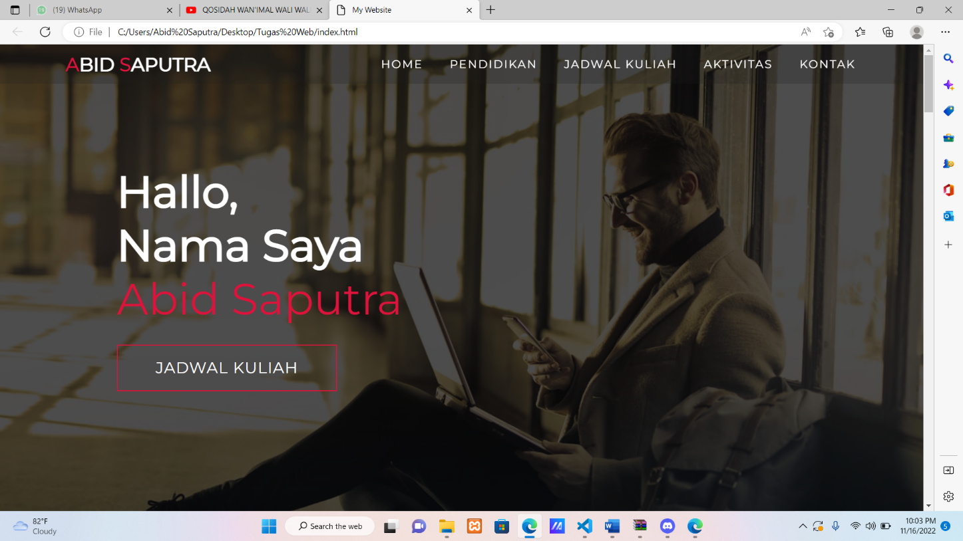

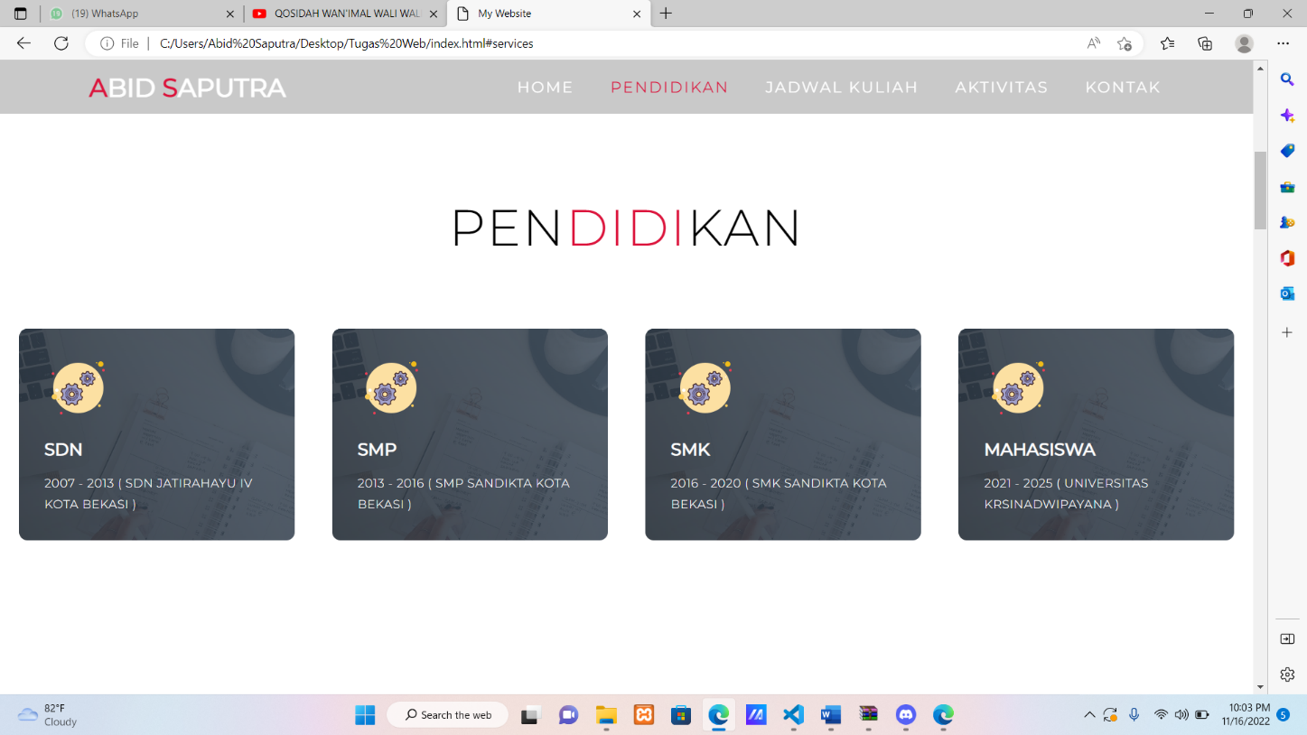

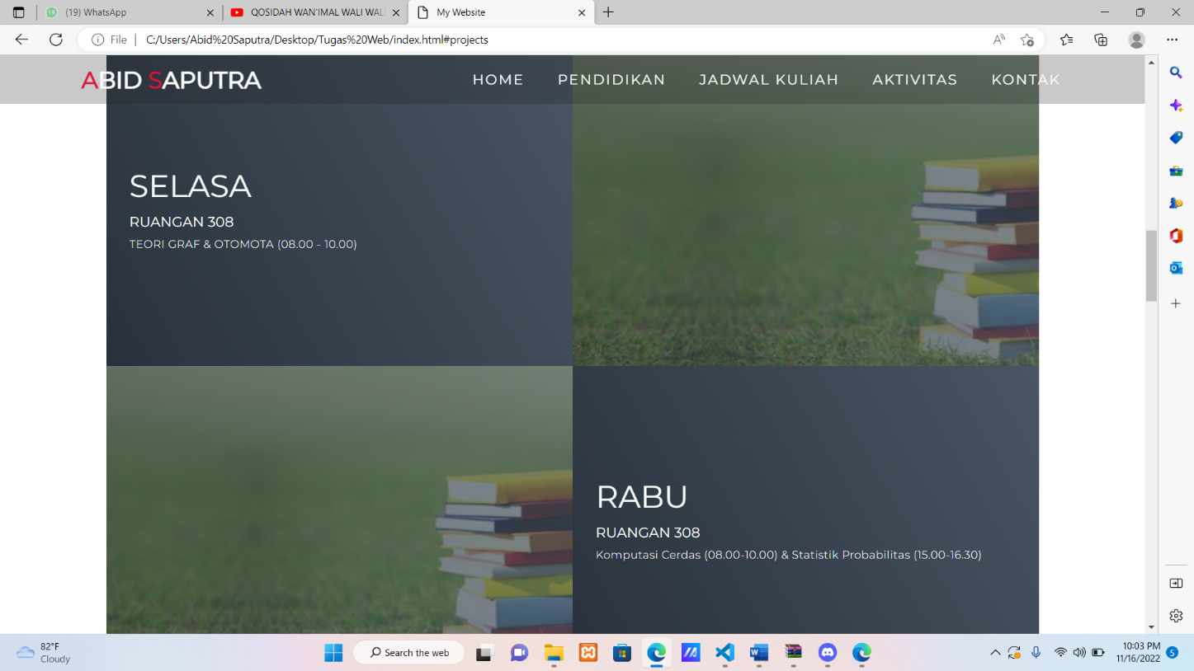

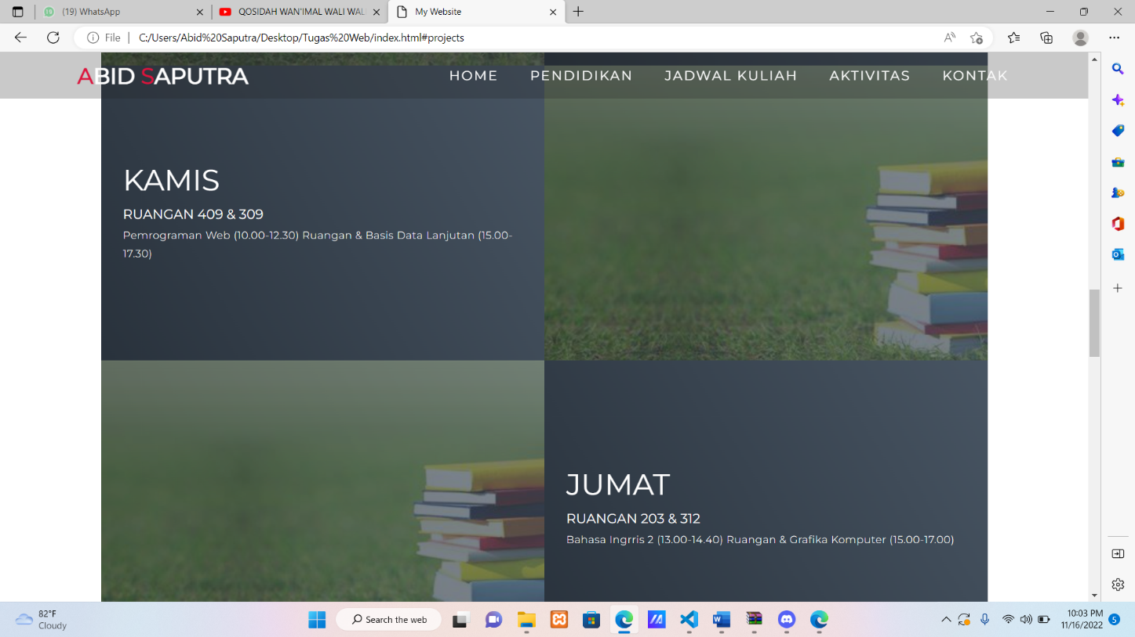

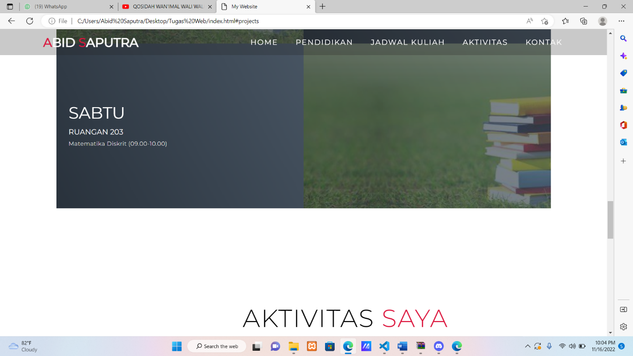

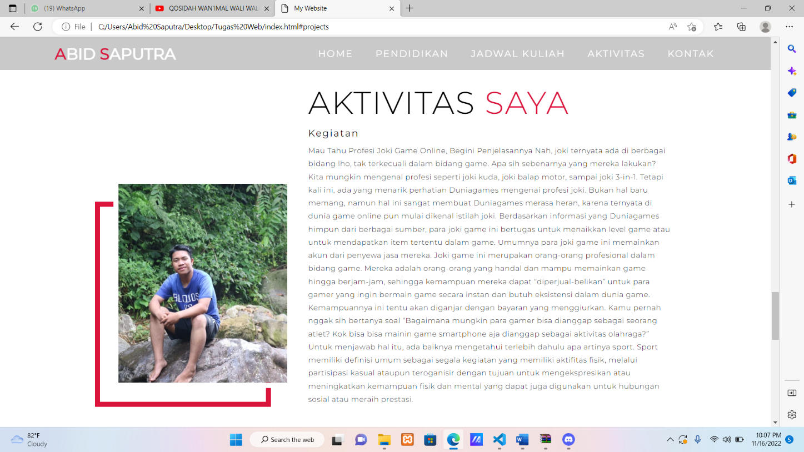

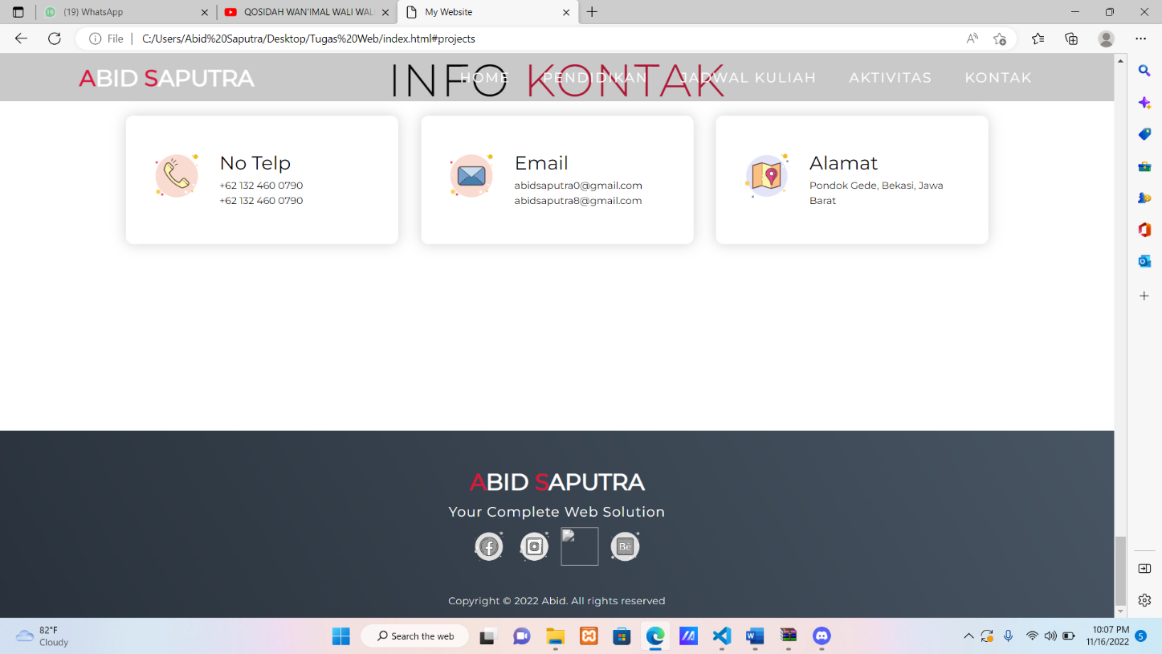

**PERTEMUAN 3 (JAVASCRIPT)**

Latihan 1

* input

<!DOCTYPE html>

<html>

<head>

    <title>Alert Box</title>

</head>

<body>

<script language="JavaScript">

//<!-

window. alert("Ini Merupakan Pesan Untuk Anda");

//->

</script>

</body>

</html>

* output

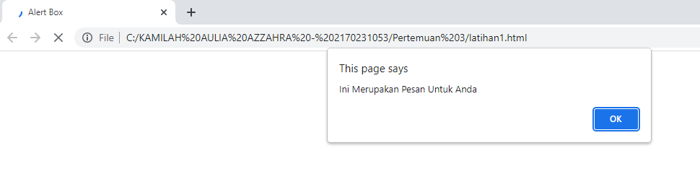

Latihan 2

* input

<!DOCTYPE html>

<html>

<head>

    <title>Skrip JavaScript</title>

</head>

<body>

Percoban Memakai JavaScript: <br>

<script language="JavaScript">

//<!-

document.write("Selamat Mencoba JavaScript<br>"); document.write("Semoga Sukses");

//->

</script>

</body>

</html>

* output

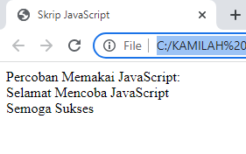

Latihan 3

* input

<!DOCTYPE html>

<html>

<head>

    <title>Pemasukan Data</title>

</head>

<body>

<script language="JavaScript">

//<!-

var nama = prompt("Siapa Nama Anda?", "Masukkan Nama Anda"); document.write("Hai," +nama);

//->

</script>

</body>

</html>

* output

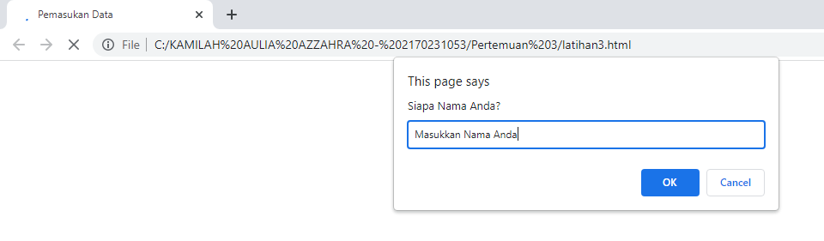

Latihan 4

* input

<!DOCTYPE html>

<html>

<head>

    <title>Contoh Program JavaScript</title>

</head>

<script language="JavaScript">

function pesan() {

alert ("Memanggil JavaScript lewat Body Onload")

}

</script>

<body onload=pesan()>

</body>

</html>

* output

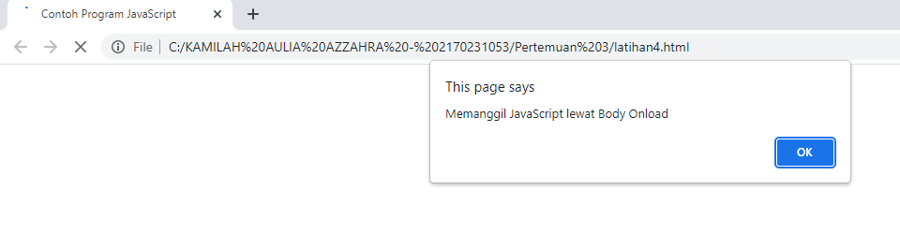

Latihan 5

* input

<!DOCTYPE html>

<html>

<head>

    <title>Contoh Program JavaScript</title>

</head>

<script language="JavaScript">

function test(val1,val2)

{

document.write("<br>"+"Perkalian : val1*val2"+"<br>")

document.write(val1*val2)

document.write("<br>"+"Pembagian : val1/val2"+"<br>")

document.write(val1/val2)

document.write("<br>"+"Penjumlahan : val1+val2"+"<br>")

document.write(val1+val2)

document.write("<br>"+"Pengurangan : val1-val2"+"<br>")

document.write(val1-val2)

document.write("<br>"+"Modulus : val1%val2"+"<br>")

document.write(val1%val2)

}

</script>

<body>

<input type="button" name="button1" value="arithmetic" onclick=test(9,4)>

</body>

</html>

* output

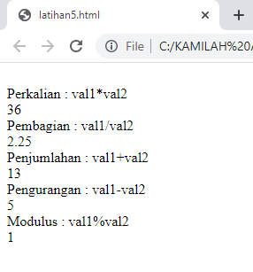

Latihan 6

* input

<!DOCTYPE html>

<html>

<head>

    <title>Contoh Program JavaScript</title>

</head>

<script language="JavaScript">

function test() {

val1=window.prompt('Nilai I :')

val2=window.prompt('Nilai II :')

document.write("<br>"+"val1==val2"+"<br>")

document.write(val1==val2)

document.write("<br>"+"val1!=val2"+"<br>")

document.write(val1!=val2)

document.write("<br>"+"val1&gtval2"+"<br>")

document.write(val1>val2)

document.write("<br>"+"val1&ltval2"+"<br>")

document.write(val1<val2)

}

</script>

<body>

<input type="button" name="button1" value="arithmetic" onclick=test()>

</body>

</html>

* output

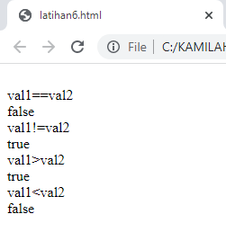

Latihan 7

* input

<!DOCTYPE html>

<html>

<head>

    <title>Contoh Program JavaScript</title>

</head>

<script language="JavaScript">

var nilai = prompt("Nilai (0-100):", 0);

var hasil = '';

if (nilai >= 60)

    hasil = 'Lulus';

else

    hasil = 'Tidak Lulus';

    document.write('Hasil:' + hasil);

</script>

<body>

</body>

</html>

* output

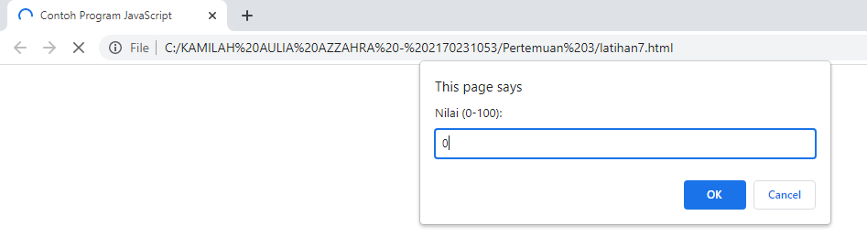

Latihan 8

* input

<!DOCTYPE html>

<html>

<head>

    <title>Contoh Program JavaScript</title>

</head>

<script language="JavaScript">

function test()

{

val1=window.prompt('Input Nilai (1-5) :')

switch(val1)

{

case'1':

document.write("Bilangan satu")

break

case'2':

document.write("Bilangan dua")

break

case'3':

document.write("Bilangan Tiga")

break

case'4':

document.write("Bilangan Empat")

break

case'5':

document.write("Bilangan Lima")

break

default:

document.write("Bilangan Lainnya")

}

}

</script>

<body>

<input type="button" name="button1" value="Switch" onclick=test()>

</body>

</html>

* output

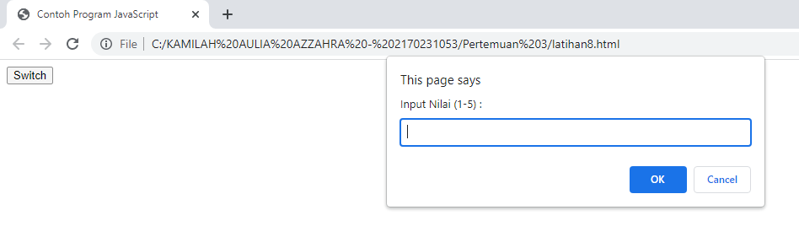

Latihan 9

* input

<!DOCTYPE html>

<html>

<head>

    <title>Contoh Program JavaScript</title>

</head>

<body>

    <script language="JavaScript">

for (x=0;x<=10;x++)

document.write(x+"<br>")

</script>

</body>

</html>

* output

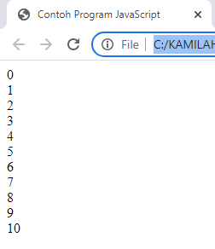

Latihan 10

* input

<!DOCTYPE html>

<html>

<head>

    <title>Contoh Program JavaScript</title>

</head>

<body>

    <script language="JavaScript">

var x=0

do{

    document.write(x+"<br>")

x++

}

while(x<=10)

</script>

</body>

</html>

* output

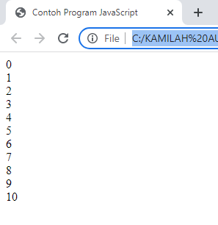

Latihan 11

* input

<!DOCTYPE html>

<html>

<head>

    <title>Contoh Program JavaScript</title>

</head>

<script language="JavaScript">

function test()

{

var val1=document.kirim. t1. value

if (val1%2==0)

document.kirim. T2. value="Bilangan Genap"

else

document.kirim. T2. value="Bilangan Ganjil"

}

</script>

<body>

<form method="POST" name="kirim">

    <p>BIL <input type="text" name="t1" size="20">Merupakan Bil <input type="text" name="T2" size="20"></p>

    <p><input type="button" value="Tebak" name="B1" onclick=test()></p>

</form>

</body>

</html>

* output

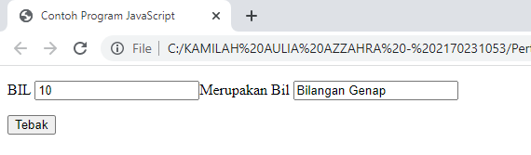

Latihan 12

* input

<!DOCTYPE html>

<html>

<head>

    <title>Objek Document</title>

</head>

<body>

<script language="JavaScript">

function ubahwarnaLB(warna)

{

document.bgColor = warna;

}

function ubahwarnaLD(warna)

{

document.fgColor = warna;

}

</script>

<h1>TES</h1>

<form>

    <input type="button" value="Latar Belakang Hijau" onclick="ubahwarnaLB('GREEN')">

    <input type="button" value="Latar Belakang Putih" onclick="ubahwarnaLB('WHITE')">

    <input type="button" value="Teks Kuning" onclick="ubahwarnaLD('YELLOW')">

    <input type="button" value="teks Biru" onclick="ubahwarnaLD('BLUE')">

</form>

</body>

</html>

* output

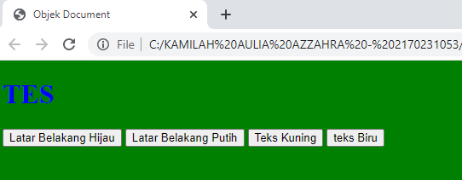

**TUGAS PERTEMUAN 3**

1. Buat halaman html untuk mengkonversi nilai angka menjadi nilai huruf dengan menggunakan javascript . Konversi : 0-40 =E

41-55=D

56-60=C

61-65=BC 66-70=B 71-80=AB 81-100=A

<html>

    <head>

        <title>Tugas no.1</title>

    </head>

    <script language="Javascript">

        var nilai = prompt("Nilai(0-100): ", 0);

        var hasil = "";

        if(nilai >= 0 && nilai <=40){

        hasil ="E";}

        else if(nilai >= 41 && nilai <= 55){

        hasil ="D";}

        else if(nilai >=56 && nilai <= 60){

        hasil ="C";}

        else if(nilai >=61 && nilai <= 65){

        hasil ="BC";}

        else if(nilai >=66 && nilai <= 70){

        hasil ="B";}

        else if(nilai >= 71 && nilai <= 80){

        hasil ="AB";}

        else {

        hasil ="A";}

        document.write('Grade Anda:' + hasil );

    </script>

</html>

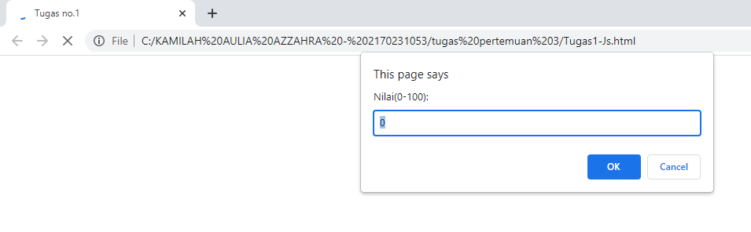

2. Buat halaman html untuk menampilkan aplikasi program kalkulator sederhana dengan menggunakan javascript.

<!DOCTYPE html>

<html lang="en">

<head>

    <meta charset="UTF-8">

    <meta http-equiv="X-UA-Compatible" content="IE=edge">

    <meta name="viewport" content="width=device-width, initial-scale=1.0">

    <title>Document</title>

</head>

<body>

    bilangan 1: <input type="text" name="bil1" id="bil1"><br> bilangan 2: <input type="text" name="bil2" id="bil2"><br> Operator:

    <input type="submit" value="+" id="tambah">

    <input type="submit" value="-" id="kurang">

    <input type="submit" value="*" id="kali">

    <input type="submit" value="/" id="bagi"><br> Hasil: <input type="text" name="hasil" id="hasil">

    <script>

        const bil1 = document.getElementById('bil1')

        const bil2 = document.getElementById('bil2')

        const tambah = document.getElementById('tambah')

        const kurang = document.getElementById('kurang')

        const kali = document.getElementById('kali')

        const bagi = document.getElementById('bagi')

        const hasil = document.getElementById('hasil')

        tambah.addEventListener('click', () => {

            let result = Number(bil1.value) + Number(bil2.value)

            hasil.setAttribute('value', result)

        })

        kurang.addEventListener('click', () => {

            let result = Number(bil1.value) - Number(bil2.value)

            hasil.setAttribute('value', result)

        })

        kali.addEventListener('click', () => {

            let result = Number(bil1.value) * Number(bil2.value)

            hasil.setAttribute('value', result)

        })

        bagi.addEventListener('click', () => {

            let result = Number(bil1.value) / Number(bil2.value)

            hasil.setAttribute('value', result)

        })

    </script>

</body>

</html>

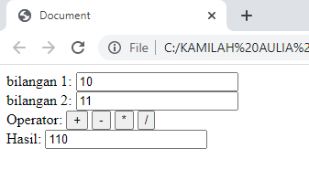

**PERTEMUAN 4 (PHP)**

Latihan 1

* input

<!DOCTYPE html>

<html lang="en">

<head>

    <title>php introduction</title>

</head>

<body>

    <?php

    $nilai_1 = 10;

    $nilai_2 = 3;

    $nilai_3 = 2 * $nilai_1 + 8 * $nilai_2;

    echo "nilai = ", $nilai_3;

    echo "<br>";

    $jumlah = $nilai_1 + $nilai_2;

    echo "hasil dari $nilai_1 + $nilai_2 adalah: $jumlah"; echo "<br><br>";

    echo "\"Nama: ABID SAPUTRA\" <br>";

    echo "2170231055";

    ?>

</body>

</html>

* output

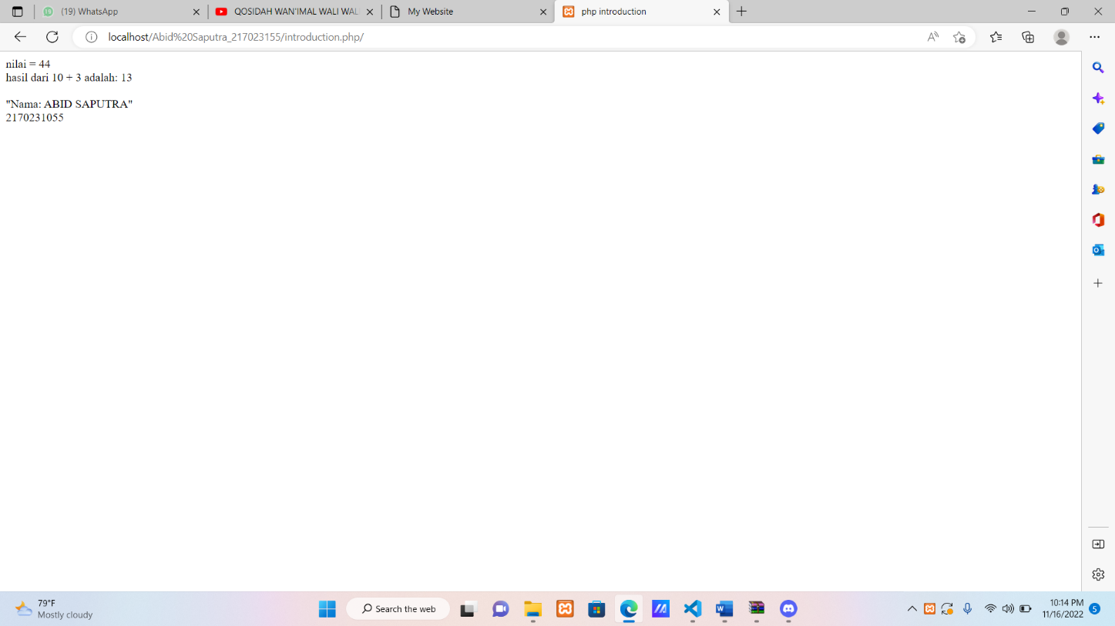

Latihan 2

* input

<!DOCTYPE html>

<html lang="en">

<head>

    <title>pemrograman php dengan Array</title>

</head>

<body>

    <?php

    $nama[]="Abid Saputra";

    $nama[]="abid";

    $nama[]="saputra";

    echo $nama[1].$nama[2].$nama[0];

    echo "<br>"

    ?>

</body>

* output

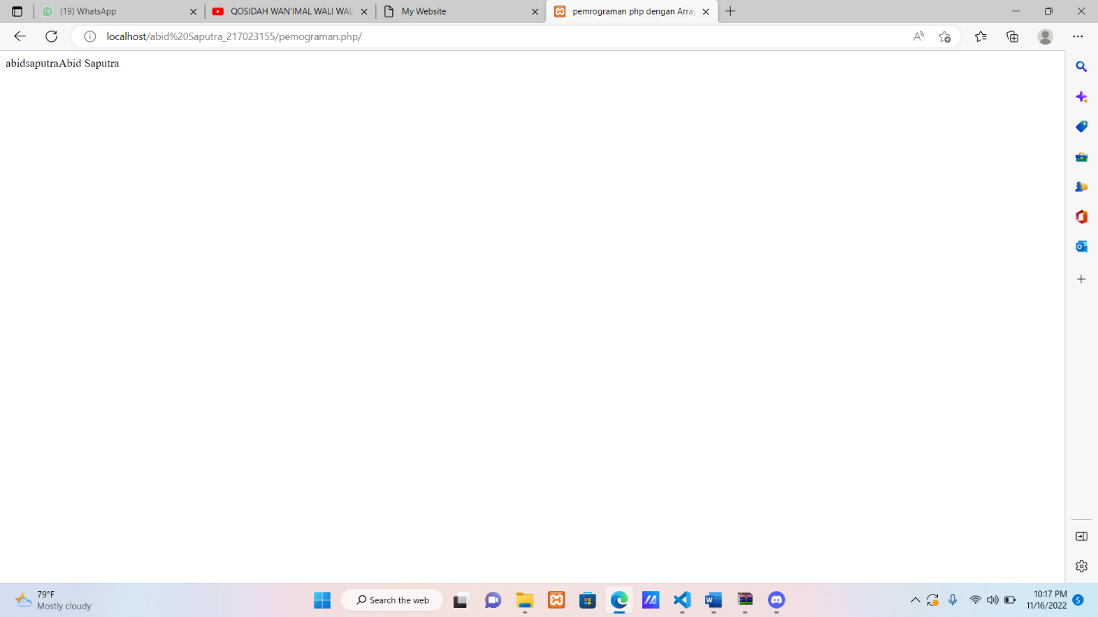

Latihan 3

* input

<!DOCTYPE html>

<html lang="en">

<head>

    <title>php introduction</title>

</head>

<body>

    <?php

    $a= 300.4;

    echo $a;

    echo "<br>";

    echo "tipe double :" , doubleval($a),"<br>";

    echo "tipe integer :",intval($a),"<br>";

    echo "tipe string :" ,strval($a);

    ?>

</body>

</html>

* output

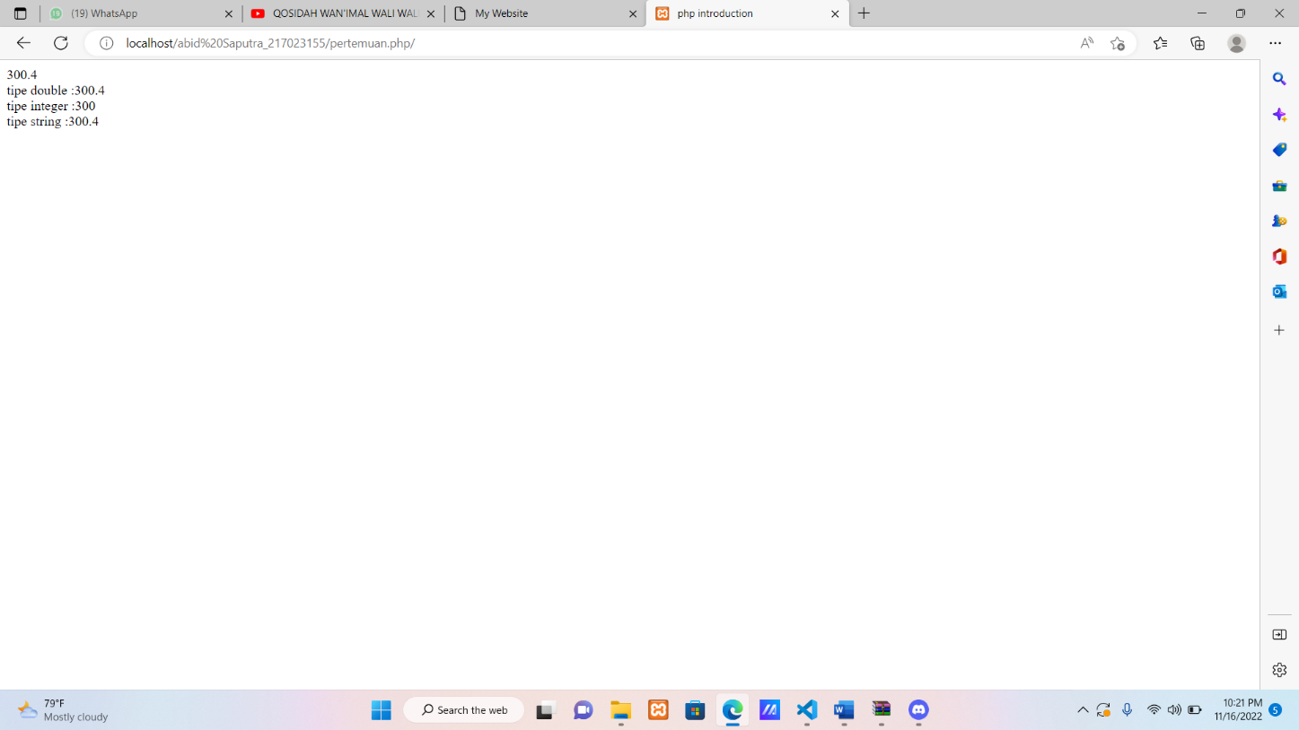

Latihan 4

* input

<!DOCTYPE html>

<html lang="en">

<head>

    <title>tanggalan</title>

</head>

<body>

    <?php

    echo date("m-F-Y, g:i:s a");

    ?>

</body>

</html>

* output

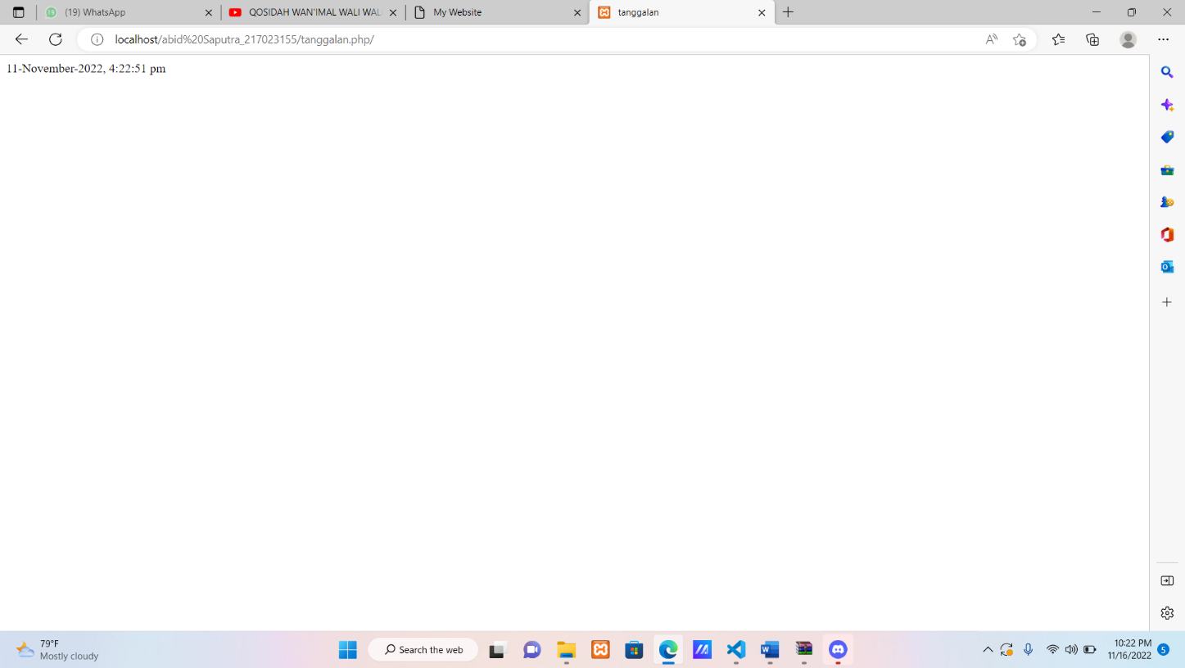

Latihan 5 (luas persegi)

* input

<html>

<head><title>LUAS PERSEGI PANJANG</title></head>

<h1>ABID SAPUTRA</h1>

<h3> APLIKASI PENGHITUNG LUAS PERSEGI PANJANG </h3>

<body>

<form actiton="" method="post">

<table border=0>

<tr>

    <td>Panjang Persegi Panjang

    <td>:

    <td><input type="text" name="panjang"><br>

</tr>

<tr>

    <td>Lebar Persegi Panjang

    <td>:

    <td><input type="text" name="lebar"><br>

</tr>

<tr>

    <td><input type="submit" name="input-data" value=Input>

</tr>

</table>

</form>

</body>

</html>

<h5> Hasil Perhitungan Luas Persegi Panjang </h5>

<?php

if (isset ($_POST["input-data"]))

{

$panjang=$_POST["panjang"];

$lebar=$_POST["lebar"];

$luas= $panjang*$lebar;

echo "Panjang Persegi Panjang Adalah : $panjang <br>";

echo "Lebar Persegi Panjang Adalah : $lebar <br>";

echo "Rumus : $panjang * $lebar <br>";

echo "Hasil : $luas";

}

?>

</body>

</html>

* output

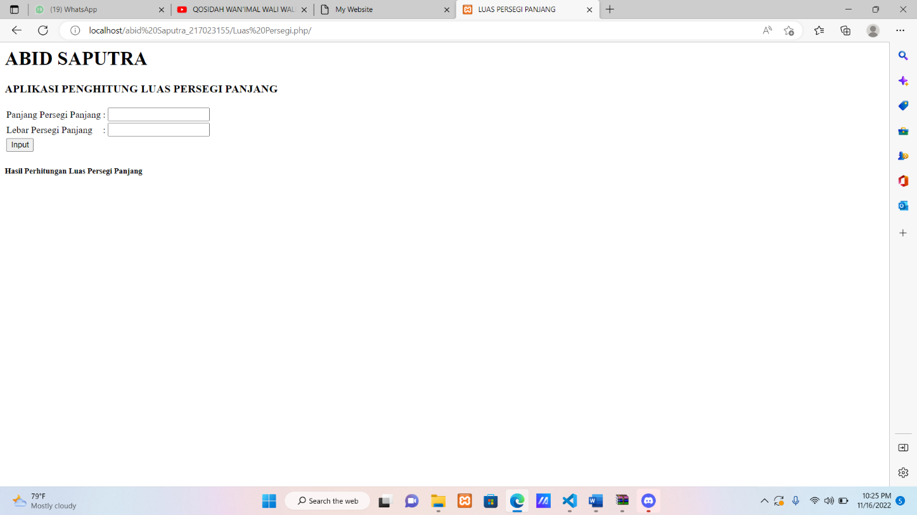

**1. $_post (“variable”)**

* input

<html>

    <head>

        <title></title>

    </head>

    <body>

        <form method="POST" action="postAct.php">

            <table>

                <tr>

                    <td width="130">Nama</td>

                    <td><input type="text" name="nama"></td>

                </tr>

                <tr>

                    <td width="130">Email</td>

                    <td><input type="text" name="email"></td>

                </tr>

                <tr>

                    <td>

                        <input type="submit" name="btnLogin" value="Login">

                        <input type="reset" name="reset" value="Reset">

                    </td>

                </tr>

            </table>

    </body>

</html>

* output

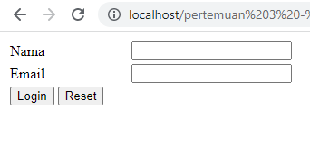

**2. Post act.php**

* input

<?php

echo "<center>Nama :" $_POST['nama'] "</center><br>";

echo "<center>Email :" $_POST['email'] "</center><br>";

?>

* output

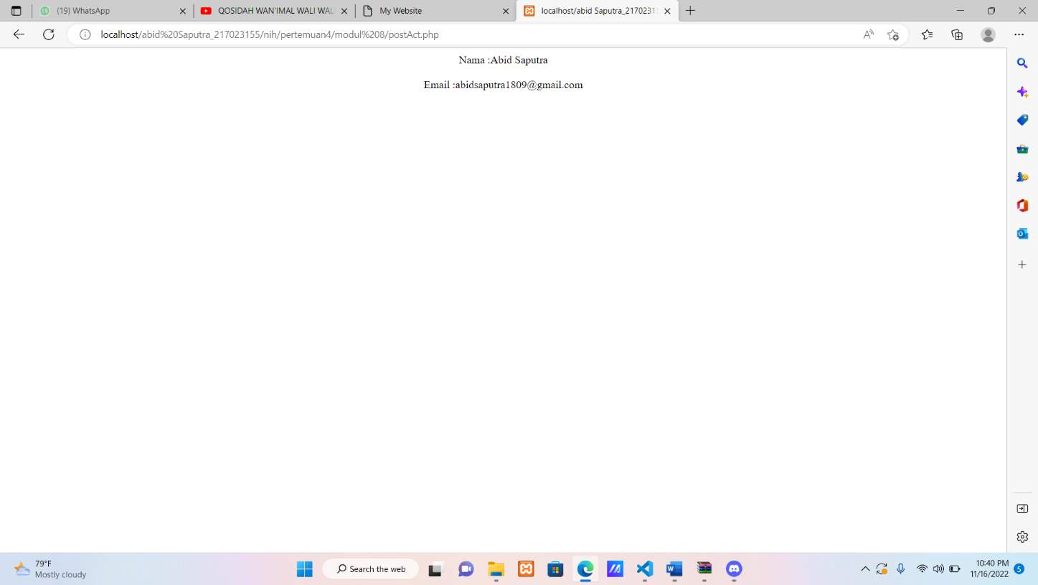

3. inc.php

* input
* <?php
* $angka=90;
* ?>
* Output

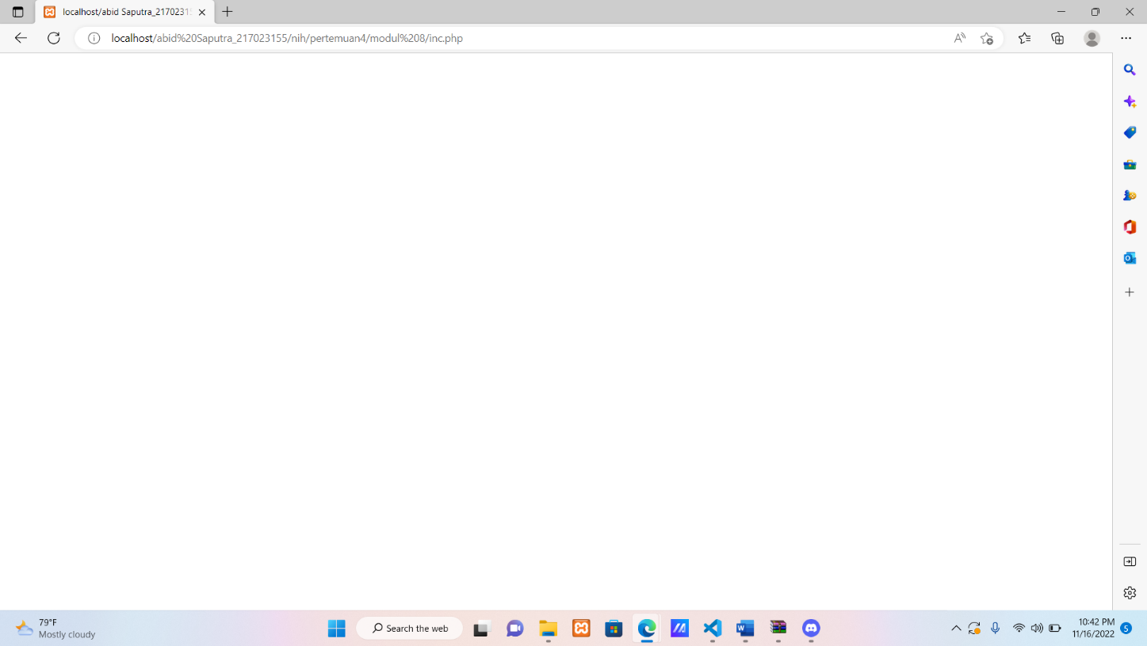

4. proses.php

* Input
* <?php
* include "inc.php";
* echo $angka;
* echo "<br>";
* if ($angka==100) {
* echo "Memuaskan";
* } elseif ($angka<100&&$angka>=85) {
* echo "Sangat Baik";
* } elseif ($angka<85&&$angka>=70) {
* echo "Baik";
* } elseif ($angka<70&&$angka>=55) {
* echo "Cukup";
* } elseif ($angka<55&&$angka>=0) {
* echo "Kurang";
* }
* ?>
* Output

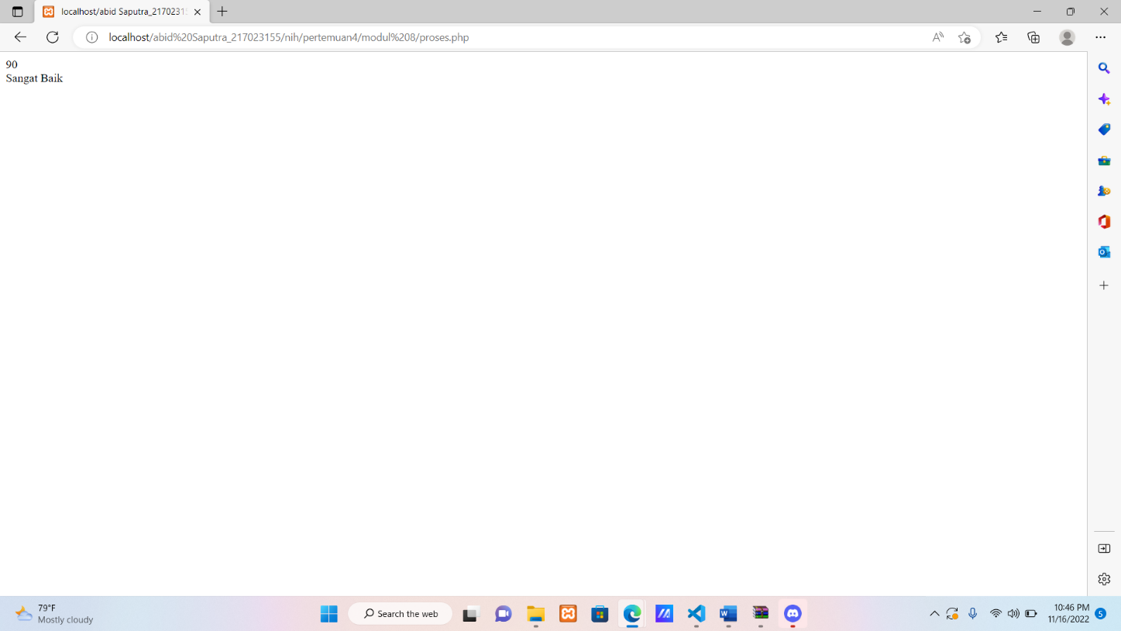

5. linkcookies.php

* Input
* <?php
* setcookie("variable_cookies", "ini adalah variable cookies",time()+60);
* echo "<a href=cekcookies.php>Cek Cookies</a>"
* ?>
* Output

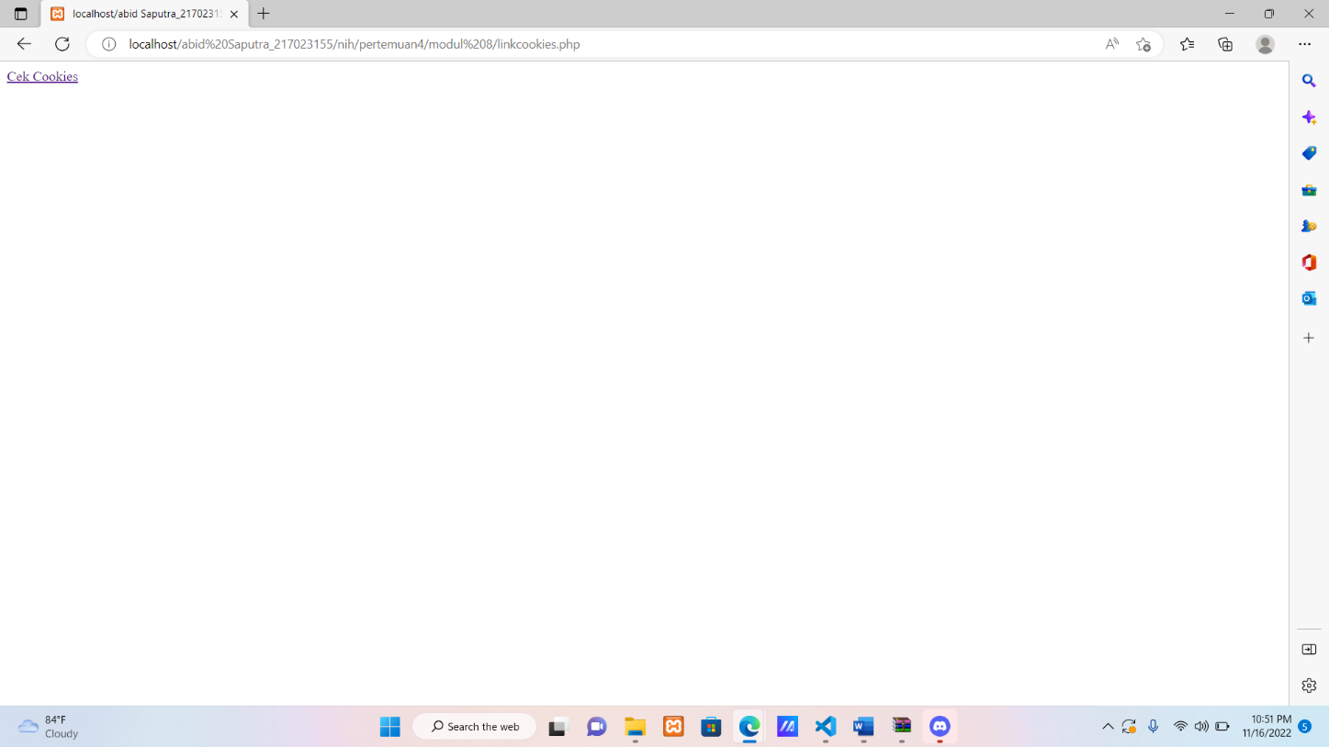

6. cekcookies.php

* Input
* <?php
* if (isset($variable_cookies)) {
* echo 'Variable Cookiesnya "$variable_cookies" nilainya adalah' .$variable_cookies;
* } else {
* echo "Variable Cookies Belum Diterapkan";
* }
* ?>
* Output

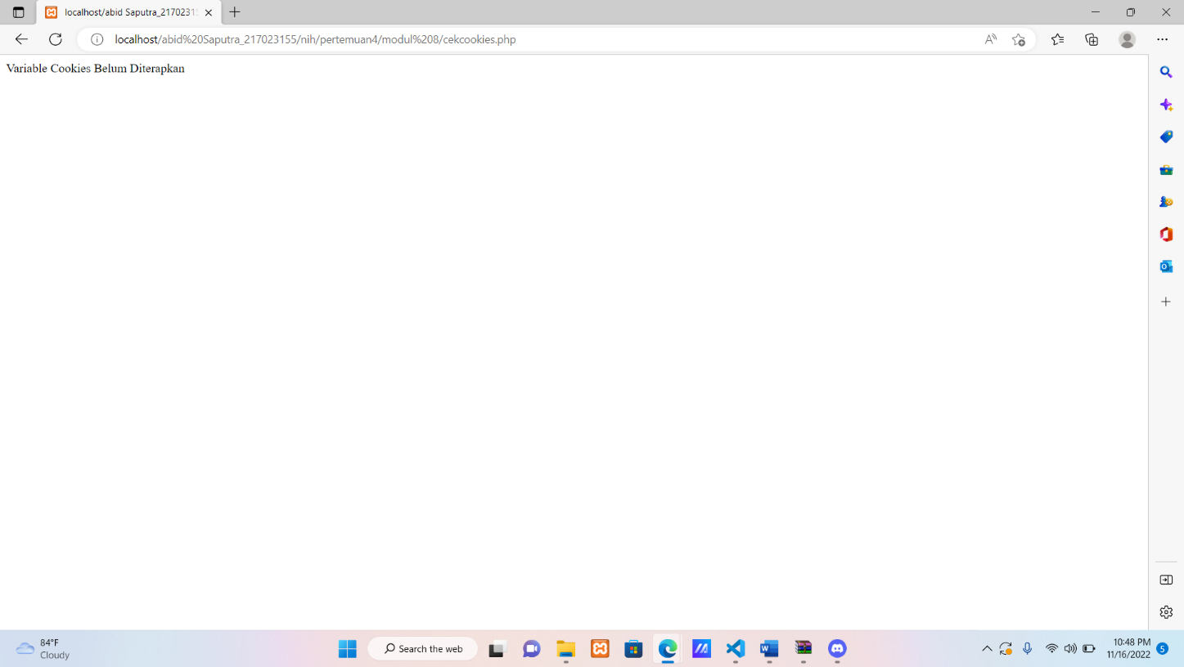

7. repair.php

* Input
* output

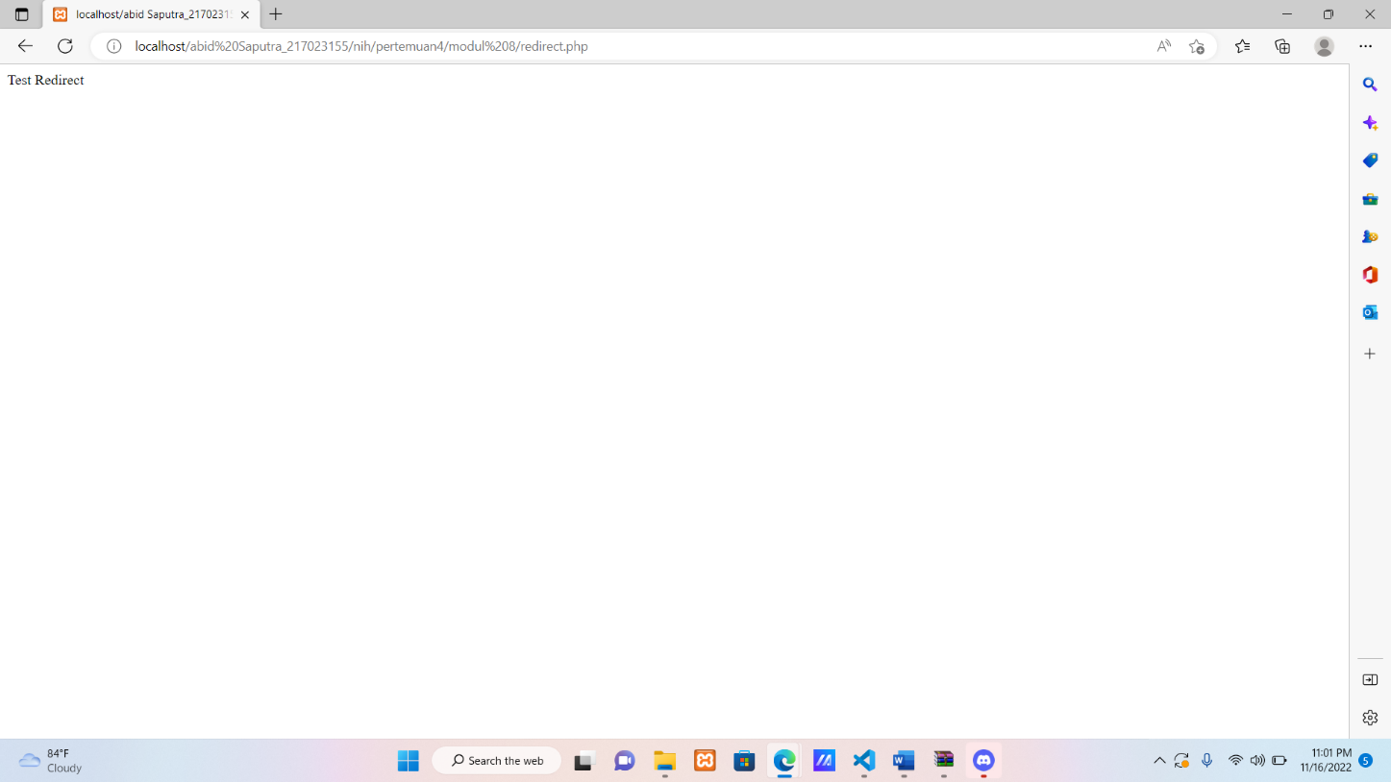

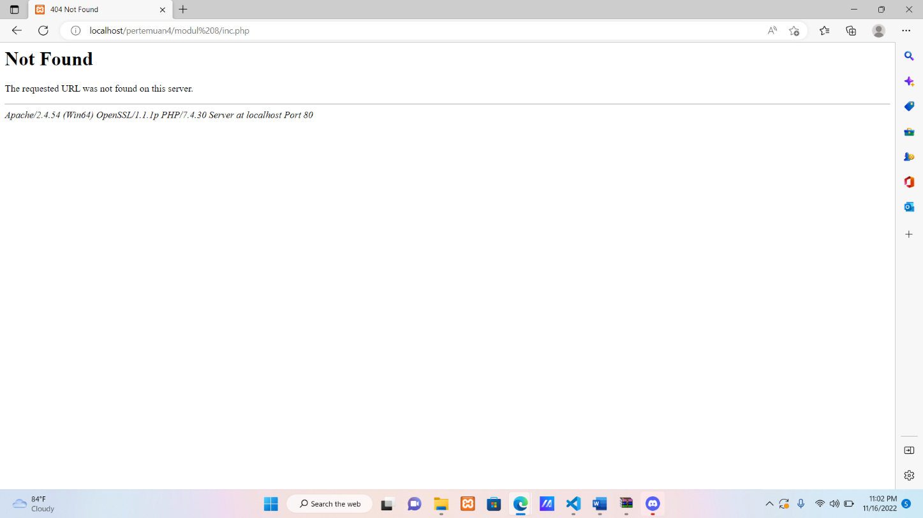

8. input.php

* input
* <!DOCTYPE html>
* <html>
* <head>
* <title>Post</title>
* </head>
* <body>
* <form method="POST" action="hasilkirim.php">
* <table width="400" align="center" cellpadding="2" cellspacing="2">
* <tr>
* <td width="130">Nama :</td>
* <td><input type="text" name="nama" ></td>
* </tr>
* <tr>
* <td colspan="2" align="center">
* <input type="submit" name="btnLogin" value="Login" >
* <input type="reset" name="reset" value="Reset" >
* </td>
* </tr>
* </table>
* </form>
* </body>
* </html>
* Output

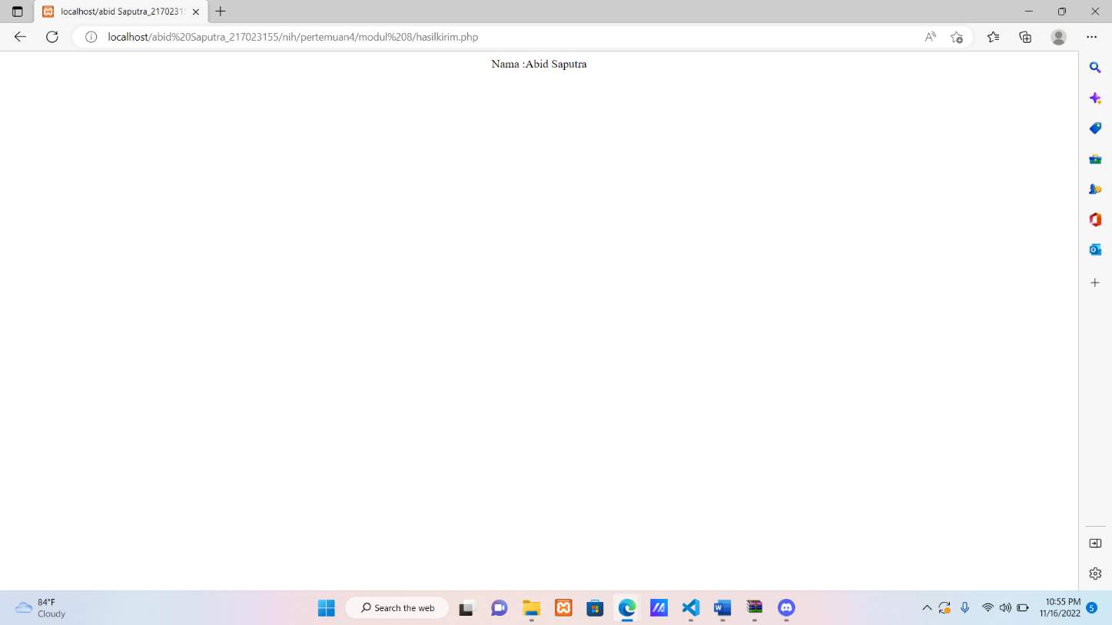

9. hasilkirim.php

* Input
* <?php
* if (empty($_POST['nama'])) {
* header("Location:kosong.php");
* } else {
* echo "<center>Nama :".$_POST['nama']."</center><br>";
* }
* ?>
* Output

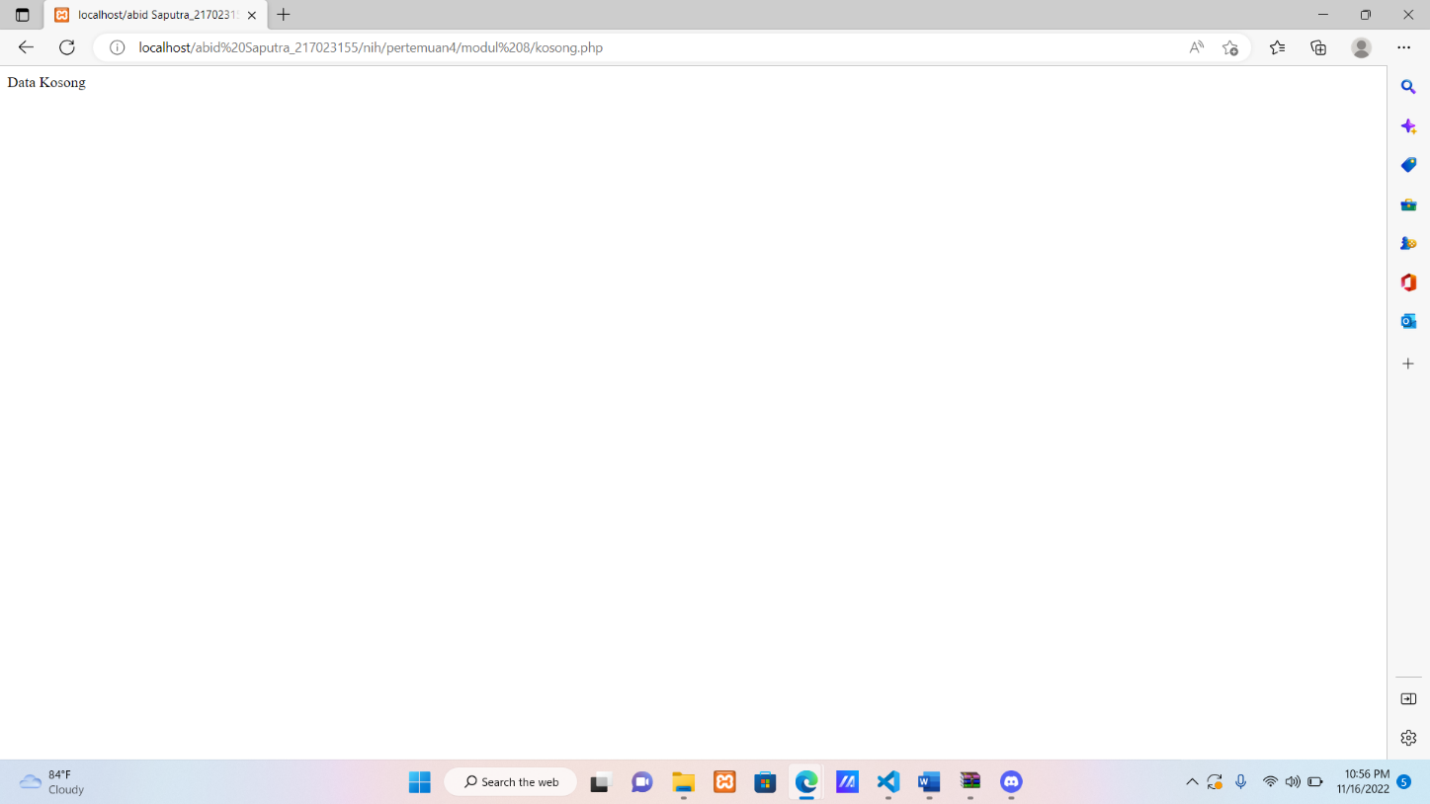

10. kosong.php

* Input
* <?php
* echo "Data Kosong";
* ?>
* Output



**TUGAS PERTEMUAN 4**

Modifikasilah program pada praktik 7 untuk menampilkan informasi tanggal dan

waktu dengan mencoba menggunakan format-format date lainnya.

<html lang="en">

<head>

    <title>Date</title>

</head>

<body>

<?php

        echo "1. ".date("d F Y")."<br/>";

        echo "2. ".date("l, d F Y")."<br/>";

        echo "<br/>";

        echo "3. ".date("H:i:s")."<br/>";

        echo "4. ".date("h:i:s A")."<br/>";

        echo "<br/>";

        echo "5. ".date("d/m/Y H:i:s")."<br/>";

?>

</body>

</html>

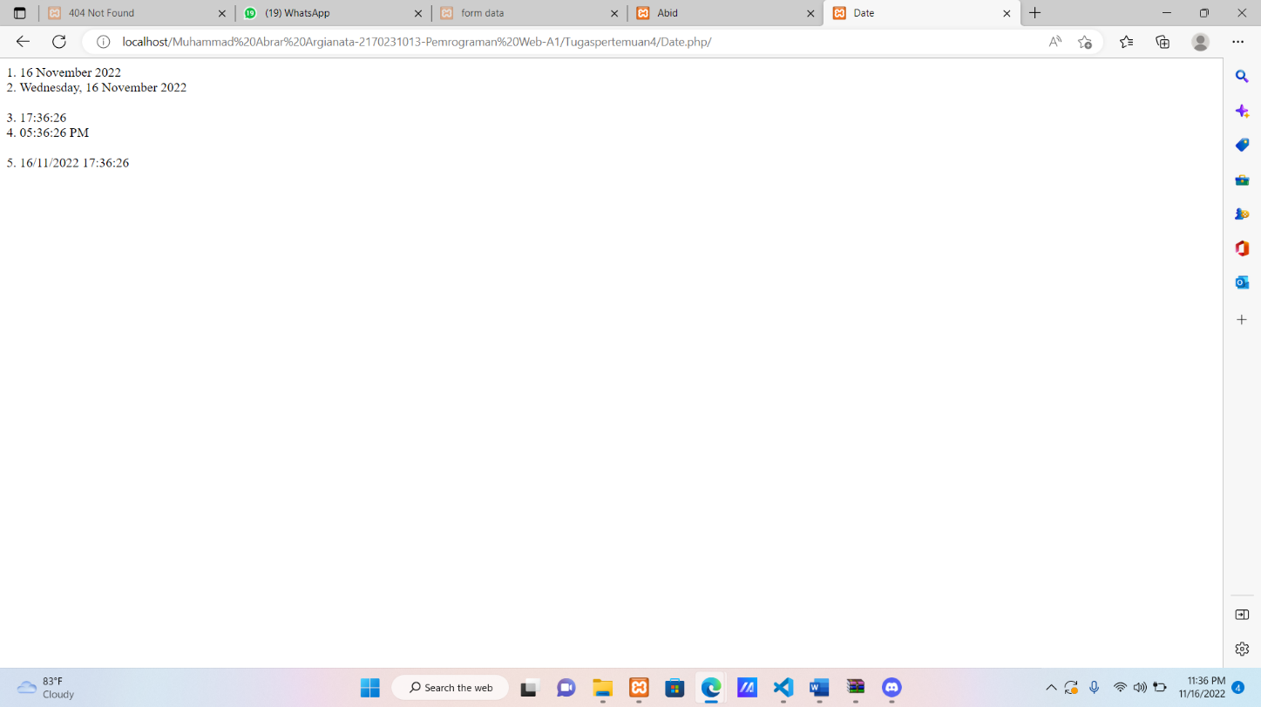

Buatlah program sederhana tentang biodata tanpa database.

<!DOCTYPE html>

<html lang="en">

<head>

    <title>form data</title>

</head>

<body>

    <h1>Biodata</h1>

    <form method="POST" action="hasil.php">

        <table rules="rows">

        <tr>

                <td>Nama</td>

                <td><input type="text" name="nim"</td>

            </tr>

            <tr>

                <td>Nim</td>

                <td><input type="text" name="nama"</td>

            </tr>

            <tr>

                <tr>

                    <td>Tanggal lahir</td>

                    <td><input type="date" name="tgllahir"</td>

                </tr>

                <tr>

                    <td>Alamat</td>

                    <td><input type="text" name="alamat"</td>

                </tr>

                <tr>

                    <td>Hobi</td>

                    <td><input type="text" name="hobi"</td>

                </tr>

                <td>Jenis Kelamin</td>

                <td><input type="radio" name="sts" value="Laki-Laki"> Laki-Laki

                <input type="radio" name="sts" value="Perempuan"> Perempuan</td>

            </tr>

        </table>

        <br>

        <button type="submit" name="submit" value="Submit">Proses Data</button>

        <button type="reset" name="reset" value="reset">reset</button>

</body>

</html>

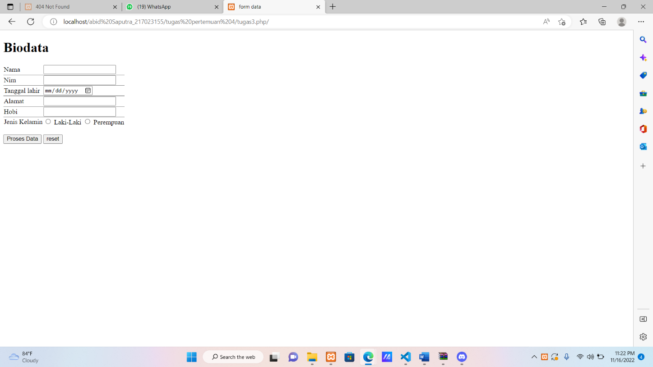

MODUL 8

Buatlah form login dengan melakukan include pada halaman web anda

yang akan menampilkan nama anda, email, jam, hari, dan tanggal login

setela login tanpa menggunakan database dengan menggunakan method get atau post!

<?php

include('proses_biodata.php');

?>

<!doctype html>

<html lang="en">

<head>

    <meta charset="utf-8">

    <meta name="viewport" content="width=device-width, initial-scale=1">

    <title>Abid</title>

    <link href="https://cdn.jsdelivr.net/npm/bootstrap@5.2.2/dist/css/bootstrap.min.css" rel="stylesheet" integrity="sha384-Zenh87qX5JnK2Jl0vWa8Ck2rdkQ2Bzep5IDxbcnCeuOxjzrPF/et3URy9Bv1WTRi" crossorigin="anonymous">

</head>

<body>

    <div class="mx-3">

        <form method="post" action="form_biodata.php">

            <div class="mb-3">

                <label for="exampleInputEmail1" class="form-label">Name</label>

                <input type="text" class="form-control" id="exampleInputEmail1" aria-describedby="emailHelp" name="name">

            </div>

            <div class="mb-3">

                <label for="exampleInputEmail1" class="form-label">Email address</label>

                <input type="email" class="form-control" id="exampleInputEmail1" aria-describedby="emailHelp" name="email">

                <div id="emailHelp" class="form-text">We'll never share your email with anyone else.</div>

            </div>

            <button type="submit" class="btn btn-primary" name="submit">Submit</button>

        </form>

        <?php

        if (isset($_POST['submit'])) {

            echo $name;

            echo '<br>';

            echo $email;

            echo '<br>';

            echo $date;

        } ?>

    </div>

    <script src="https://cdn.jsdelivr.net/npm/bootstrap@5.2.2/dist/js/bootstrap.bundle.min.js" integrity="sha384-OERcA2EqjJCMA+/3y+gxIOqMEjwtxJY7qPCqsdltbNJuaOe923+mo//f6V8Qbsw3" crossorigin="anonymous"></script>

</body>

</html>

